Dapoli Education Society’s
Dapoli Urban Senior Science College Dapoli, Ratnagiri
DEPT. OF LIFELONG LEARNING
AND EXTENSION (DLLE)
ANNUAL REPORT
ACADEMIC YEAR 2019-20

GOALS AND OBJECTIVES

- To provide career orientation and job orientation to the college students
- To bridge the knowledge gap between the College, University and the Community.
- To enhance employability of the students.
- To provide opportunity to the students for development of marketable work skills.
- To give opportunity to the students to apply classroom knowledge for the benefit of the community (Lab to Land).
- To make the students aware of social problems in the community and
- To enable the students to find their socio-cultural roots.
Composition of committee
Mrs. GORE G.S. (Coordinator/extension teacher)
- Miss Remje Ashwini.
- Miss Dhayalkar ManishaGanpat
- Miss RautTejali Vijay
- Mr. Shantanu Kadam
- Mr. Sujit Temkar
Dates Of Meeting Conducted
- 15/06/2019
- 08/07/2019
- 26/08/2019
- 14/12/2019
- 14/01/2020

Dates of Term Training Conducted
- First Term Training to Teachers and Students of Extension Work at, Lanja college. -17/06/2019
- First Term Training to Teachers and Students of Extension Work in college-26/08/2019
- Second Term Training to Teachers and Students of Extension Work at Navnirman Shikshan Sanstha’s College of arts, commerce and science , Lovale, tal- Sangmeshwar.-17/12/2019
- Second Term Training to Teachers and Students of Extension Work in college-14/01/2020
- Extension Work evaluation of projects meeting-.
Plans of the Activities in the Year –
- Organization of First Term Training to Teachers and Students in Extension Work of college
- Organization of Second Term Training to Teachers and Students in Extension Work of college
- Organization of lectures /demonstrations /poster exhibition /rangoli presentation/mehandi competition.
- Organization of various stalls of needful things whenever necessary.
- Organization of essay competition for DLLE students.
- Organization of Street play competition for DLLE students
- Field visit
- Training for student manager.
Activities in the Year---
- Organized poster competition and exhibition on 19/12/2019 and 21/12/2019 respectively.
- Organized Rangoli and essay competition on 18/12/2019 and 23/12/2019 respectively.
- Participated in Swachata Abhiyan on 16/12/2019.
- Street play for survey of SWS project Gimhavane.

FEATURES-
- 105 students are enrolled for this extension activity from the above 105 students 70 students successfully completed the projects for 10 grace marks under the ordinance of 0.229 A for the academic year 2019-20.

The total no. of projects completed in the year 2019-20
- Anna PoornaYojana [APY] -(Entrepreneurship Skills Development Education [ESDE] - 22
- Women Empowerment Education Programme [WEEP](SWS)- 18
- Career Skills Development Education (CP)- 16
- Population Education Programme - 23
- Total -70
- All students secured A Grade in the projects submitted to the University of Mumbai.
- Performed street play ‘Sumbharaan’
- Participated in the UDDAN FESTIVAL conducted by the University of Mumbai and achieved FIRST PRIZE in street play competition.
- APY students arranged five different stalls for each group.
- Prepared the questionery related to the WEEP (SWS)

Activities to be conducted by sWS
- Determined the area Gimhavane Build rapport with the community
- Giving information collected regarding women policy.
- Survey 25-35 women for each group
- Tabulation of collected data
- Analysis and interpretation-In this village the 30 % women’s are not aware of their right and these are under the burden of family. Some women’s are having smoking habit. To overcome these problems our DLLE unit performed street play as well as the given lecture on this problem.
- Wrote the project report
Data & records to be maintained
  - Survey Questionnaire
  - Women in the age group as decided under the guidance of teacher are to be covered in the survey

Anna PoornaYojana [APY] -(Entrepreneurship Skills Development Education [ESDE]
RELEVANCE OF THE ACTIVITY-
- To provide Entrepreneurship education to students with the knowledge, skills and motivation to encourage entrepreneurial success in a variety of situations.
- To opening a new organization (e.g. starting a new business).
- Another approach is to promote innovation or introduce new products or services or markets in existing firms.
- This approach is called corporate entrepreneurship. Public sector entrepreneurship has come into being in governments, with an increased focus on innovation and customer service.
Activities carried out by studentS
- Identified the food/ non food items like rakhi at the time of rakhipornima, provided cold drinks for students in summer season and during annual sport, provided chocolates on the chocolate day, pestries, ice-cream, sarbat and wadapav stall during annual sport and roses on rose day that are liked by students but are not available in college canteen.
- Selected a food/ non food item that have been be prepared by student them self, some had prepared from others and some that can be purchased on a large scale.
- Fixed the sale price for item.
- Arranged for its sale in college.
- Organized fifteen such sales.
- Kept an account of the cost incurred, sale proceeds etc.
- Calculated the profit made.
- Attend and participate in the Annual Competitions / Festivals of Department.
- Wrote the Report and essay.

Activities of Career Skills Development Education (CP) students
- Attended training programs at the college
- Selected a career one likes
- Arranged Interview two persons, given questionnaire
- Find out all possible information
- Prepared charts on the career
- Prepared four-page ( eight sides) booklet / pamphlet / brochure -What the worker does ,Working Conditions and Qualifications necessary
- Prepared a five minute talk on the career
- Exhibit the career in an exhibition at college
- Wrote the Project Report.
POPULATION EDUCATION PROGRAMME-
- RELEVANCE OF THE ACTIVITY
- To identify the social problem.
- To create the social awareness in the students.
- To create the awareness about the social issues among the public by performing street play, rally etc.
- Activities carried out by students
- Identified the problems of the school and prepared the street play and posters on that problem.
- Performed the street play at various places like schools, bazarpeth, college etc.
- Conducted poster competition on the problems like poshanaahar and pollution. Wrote the essay on all activities.
- ACHIEVEMENTS
- Achieved FIRST PRIZE in Zonal Level street play in UDAAN Festival Organized By University Of Mumbai At D.J. Samant Senior college of Arts, Commerce & Science, Pali , Dist –Ratnagiri ,in year 2019-20
Talents that can be developed-
- Public relations
- Self Confidence
- Critical and Analytical thinking
- Sensitivity to the Status of Women
- Understanding of Socio- economic condition
- Ability to relate with the common man
- Student of SWS projects conducting Survey Activity.
-:SWS Project:-

SWS Student Giving a talks

SWS Students at the time of survey

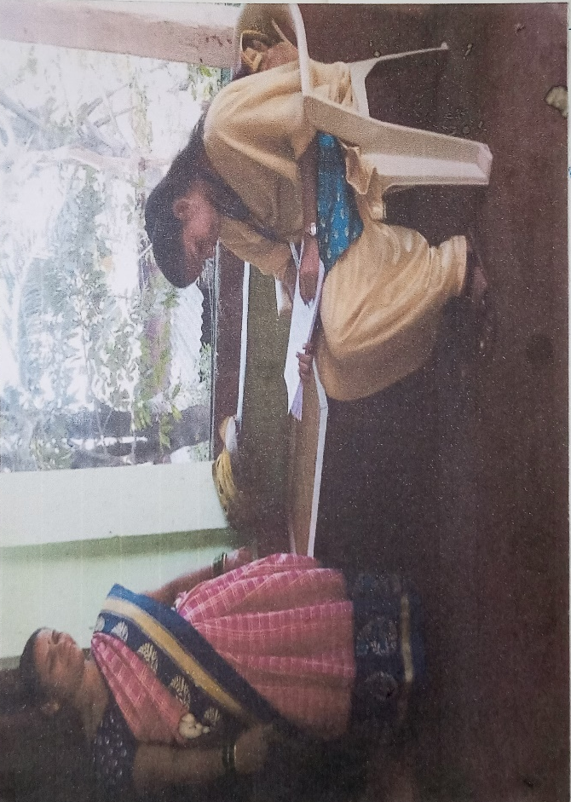
SWS Students at the time of survey
-:APY Project:-

Bhel Stall
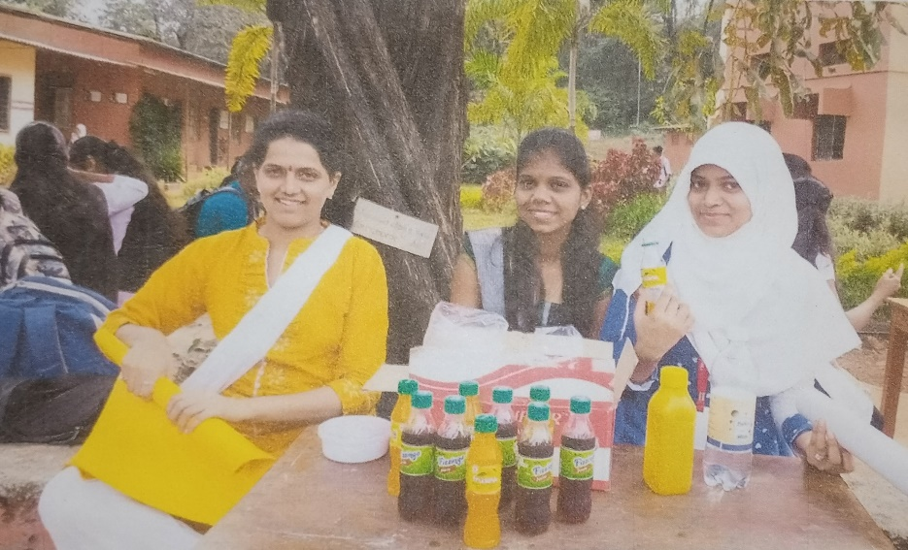
Cold drink stall
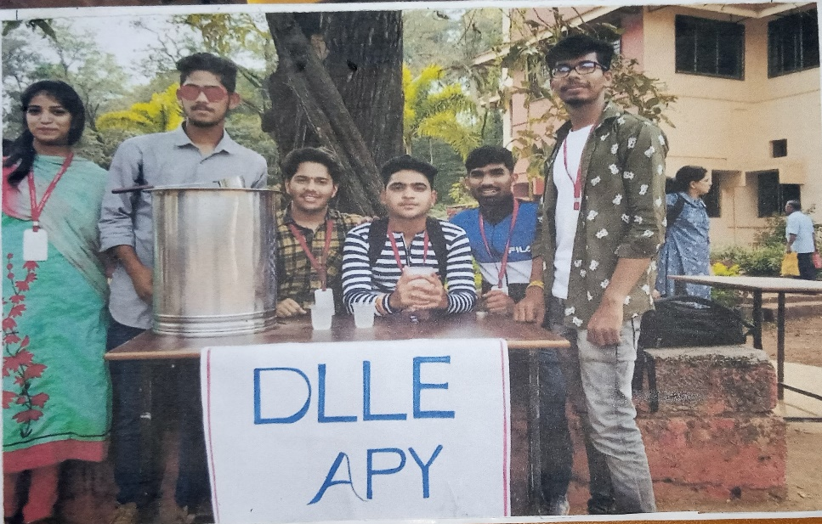
Juice stall

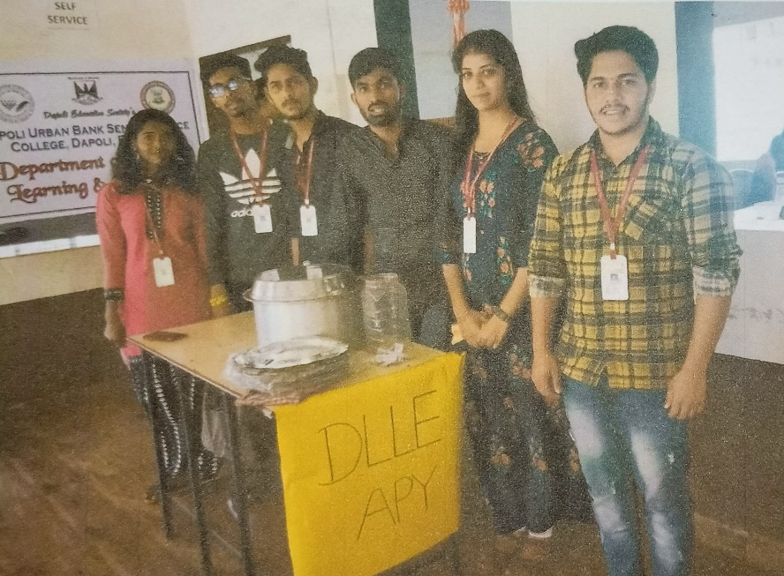
Pav Bhaji stall
-:CP Project

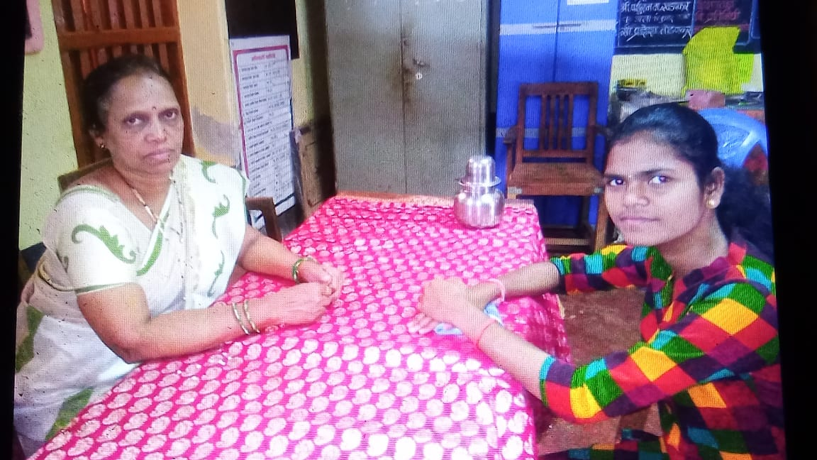
Interview of Primary Teacher
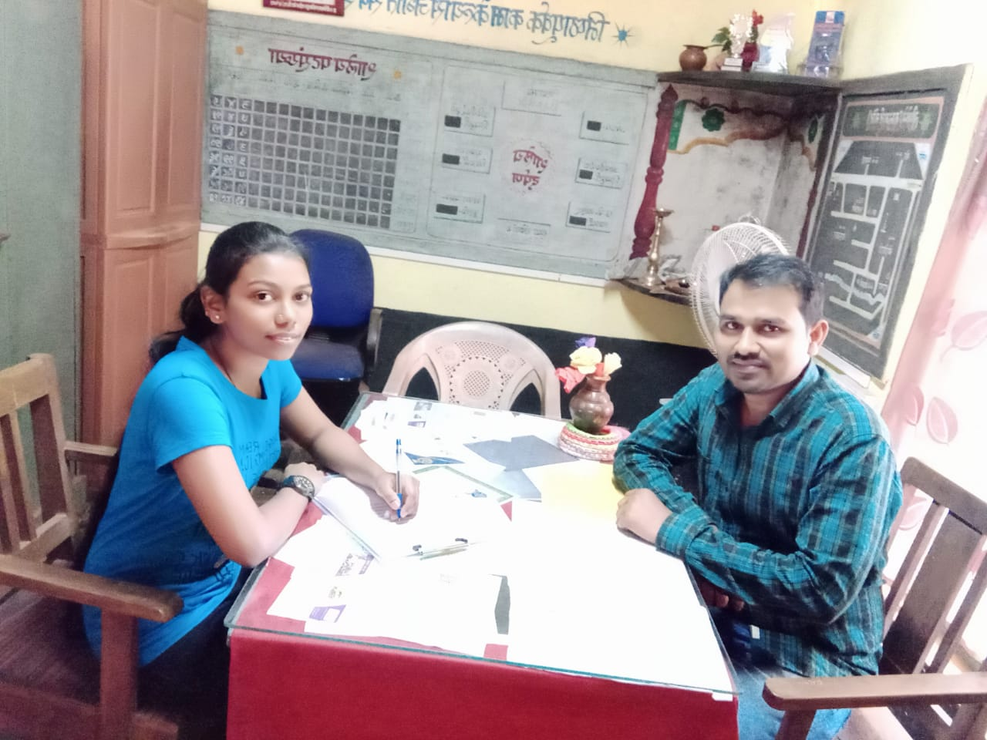
Interview of Principal

Interview of Social Worker
-:PEC Project:-

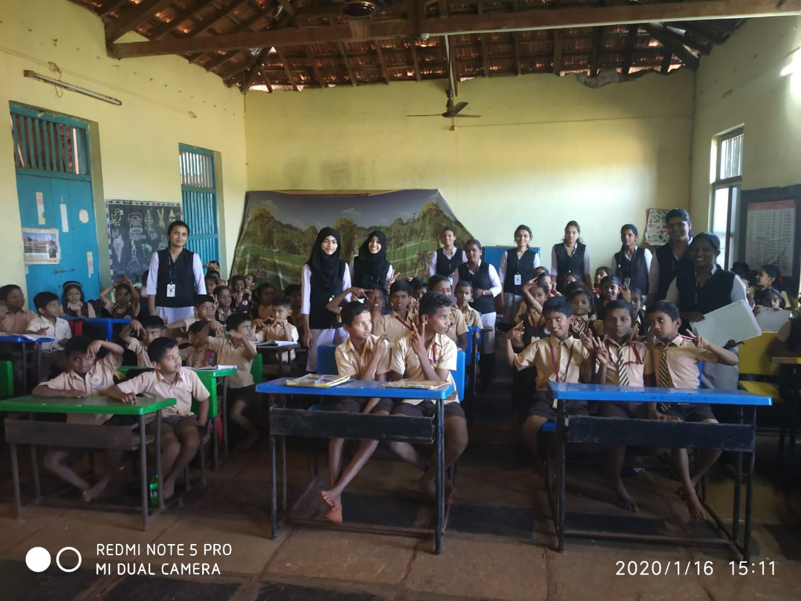
Essay and Drawing Competition at Z.P. School, Gimhavane

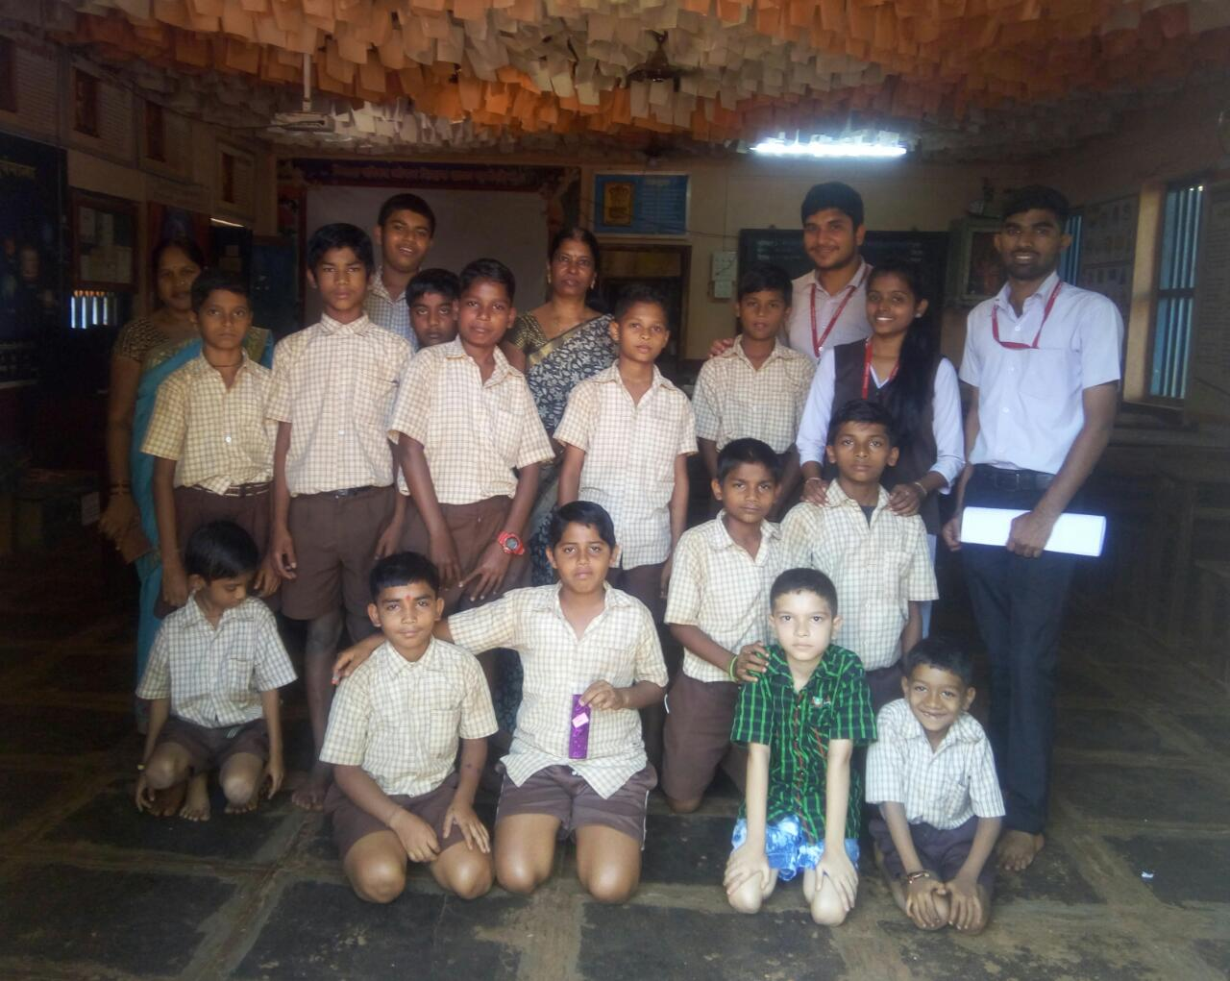
Essay Competition at Z.P. Jivan Shiksha School, Dapoli No. 1

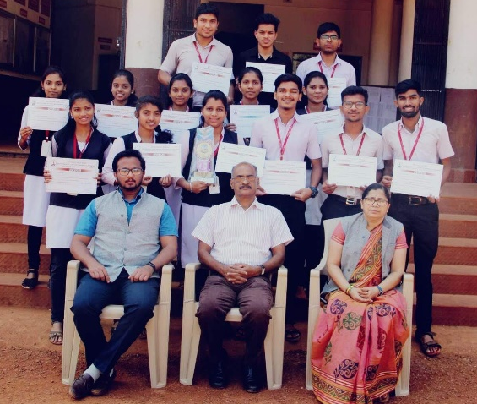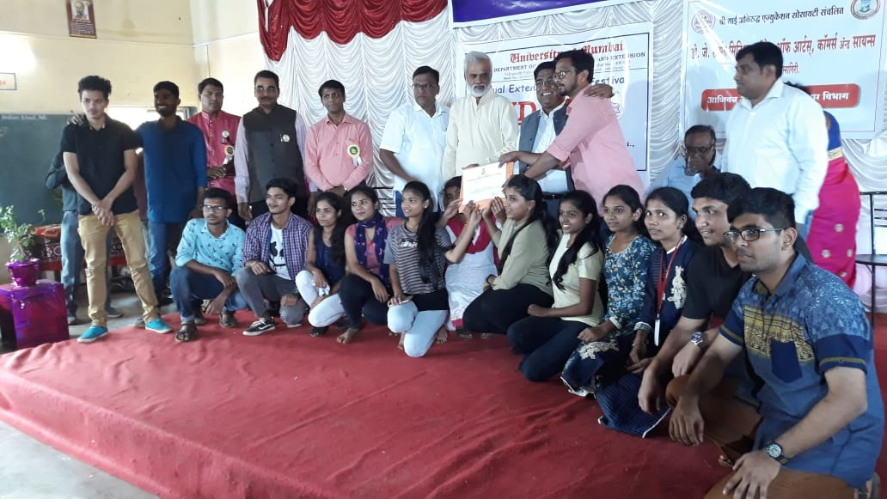
Achieved FIRST PRIZE in Zonal Level street play in UDAAN Festival Organized By University Of Mumbai At D.J. Samant Senior college of Arts, Commerce & Science, Pali , Dist –Ratnagiri ,in year 2019-20.

Extension Teacher Principal

