Dapoli Education Society’s
Dapoli Urban Senior Science College Dapoli, Ratnagiri
DEPT. OF LIFELONG LEARNING
AND EXTENSION (DLLE)
Activity REPORT
ACADEMIC YEAR 2022-23

Activity:-Anna Purnna Yojana (APY)
  - Aim:- To provide Entrepreneurship education to students with the knowledge, skills and motivation to encourage entrepreneurial success in a variety of situations.
  - To opening a new organization (e.g. starting a new business).
  - No. of Participant:-19
  - Date and Time: Through the year
  - Activities:-
  - Selected a food/ non food item that have been be prepared by student them self, some had prepared from others and some that can be purchased on a large scale.
  - Arranged 05 stalls for each group
  - Fixed the sale price for item.
  - Arranged for its sale in college.
  - Calculated the profit made.
  - Attended and participated in the Annual Competitions / Festivals of Department.
ANNAPURNA YOJNA PROJECT
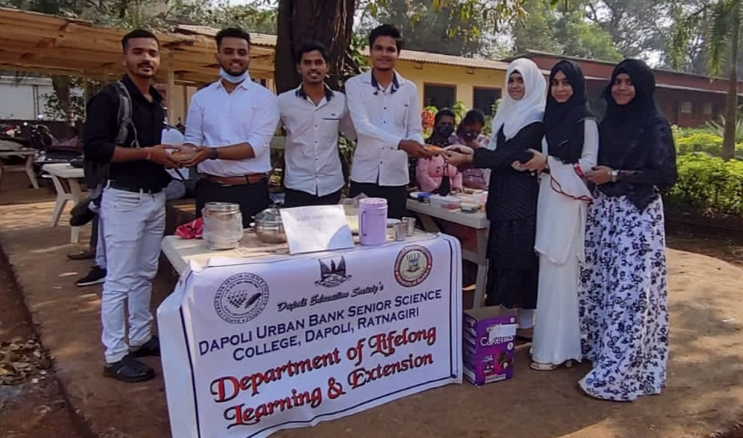

ANNAPURNA YOJNA PROJECT
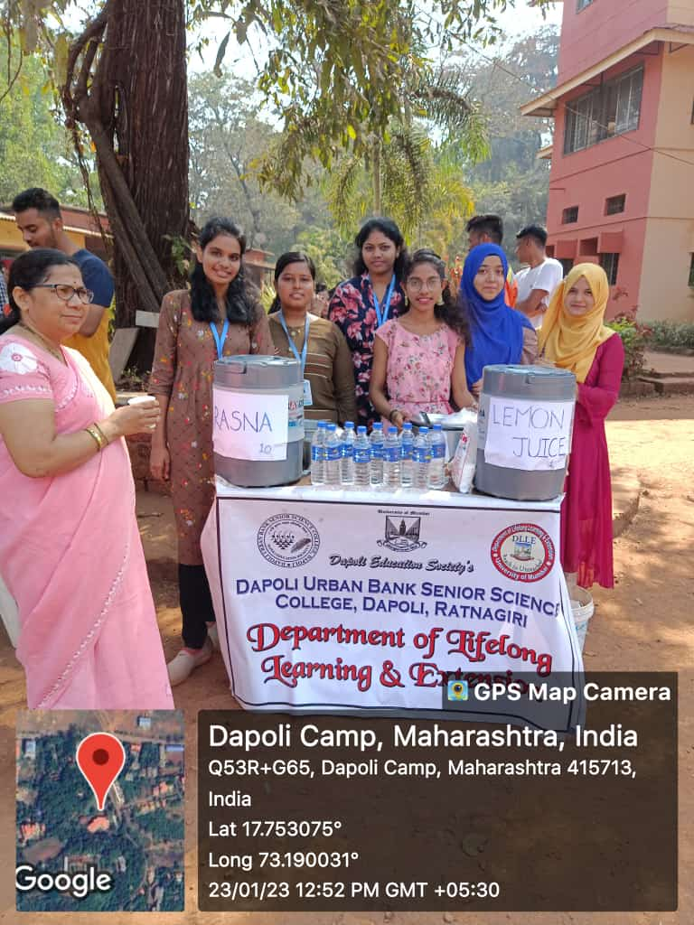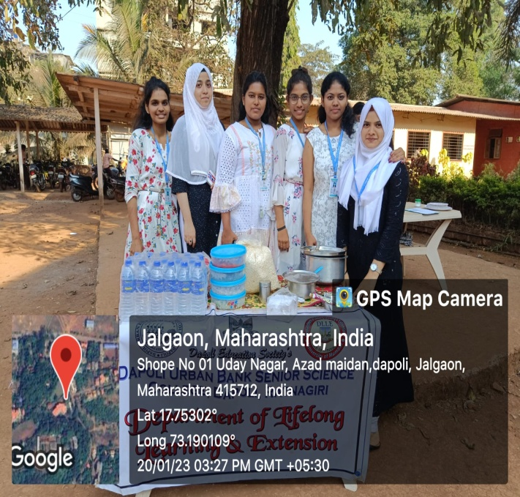
Cold drink stall Bhel stall
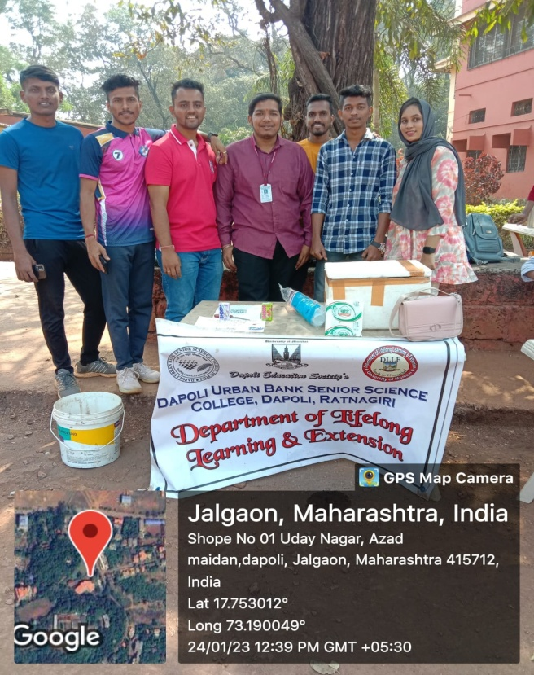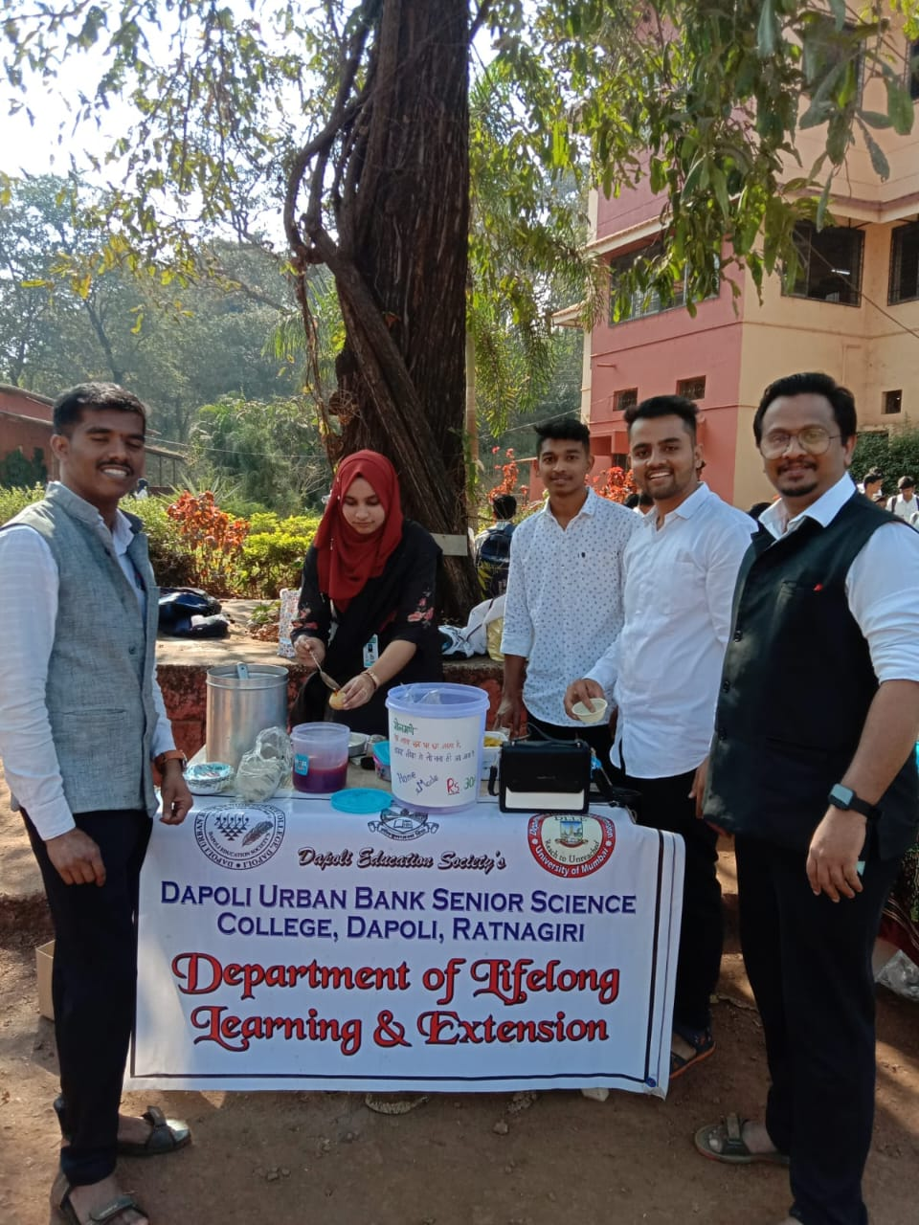
ICE CREAME STALL PANIPURI STALL
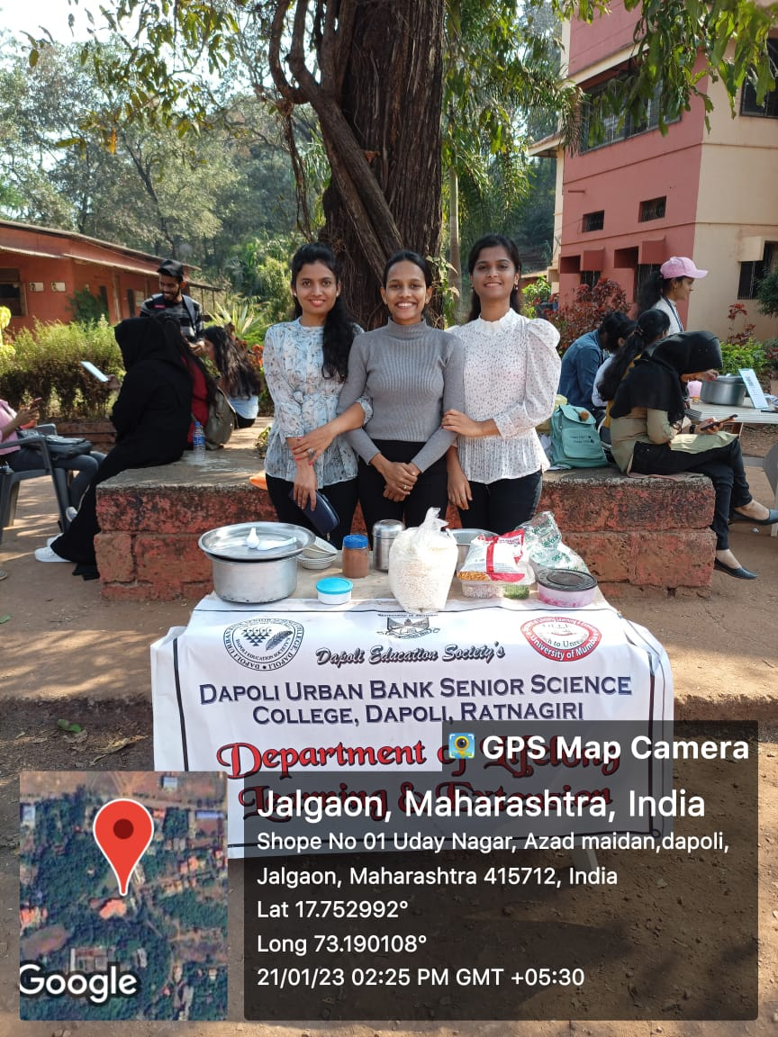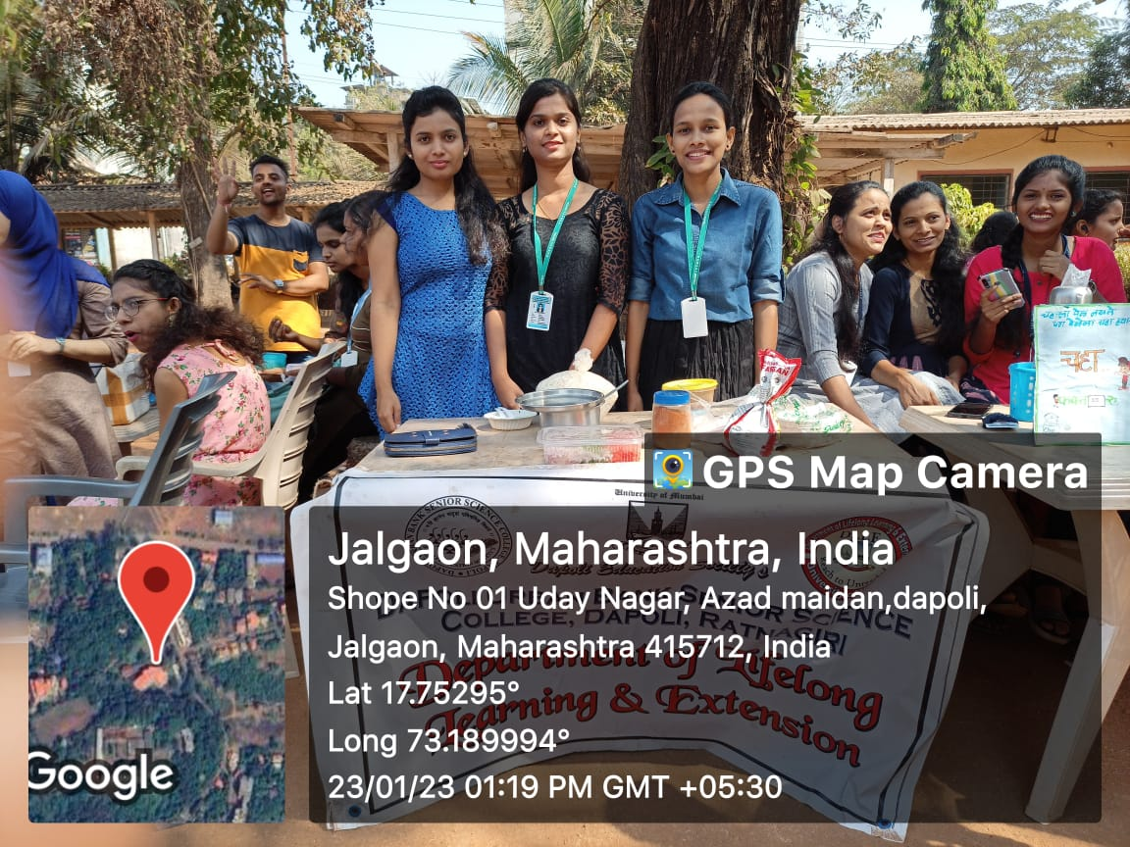
AMBOLI STALL IDALI STALL

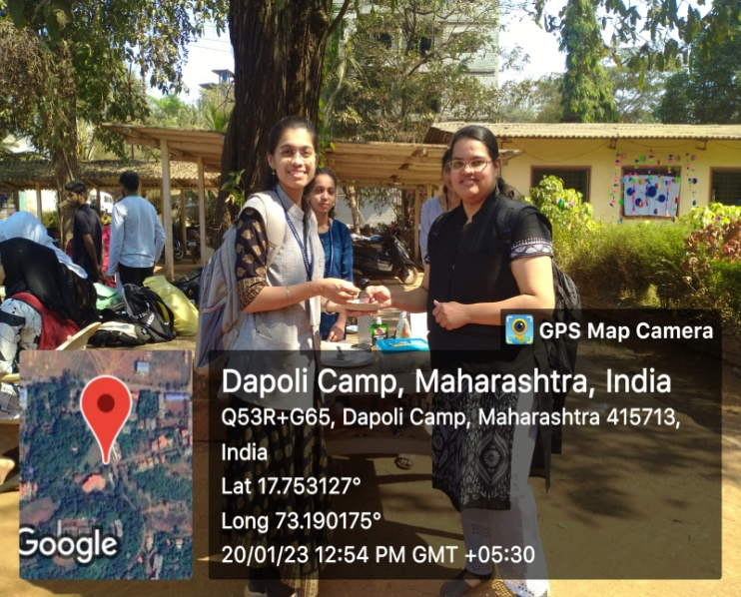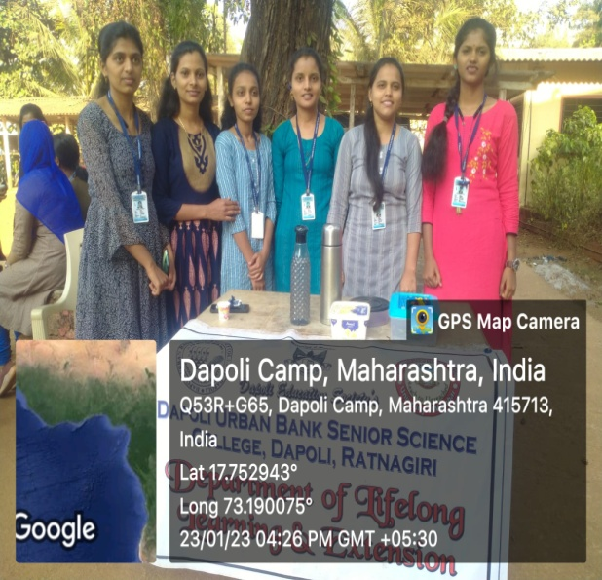
PATIS STALL COFEE STALL

Activity: - Career project (CP)
- Aim:- To provide career orientation and job orientation to the college students
- To bridge the knowledge gap between the College, University and the Community.
- To enhance employability of the students.
- No. of Participant:-08
- Date and Time: Through the year
Activities:-
- Selected a career one likes.
- Arranged Interview two persons, given questionnaire.
- Find out all possible information.
- Prepared charts on the career.
- Prepared a five minute talk on the career.

CARRIER PROJECT :
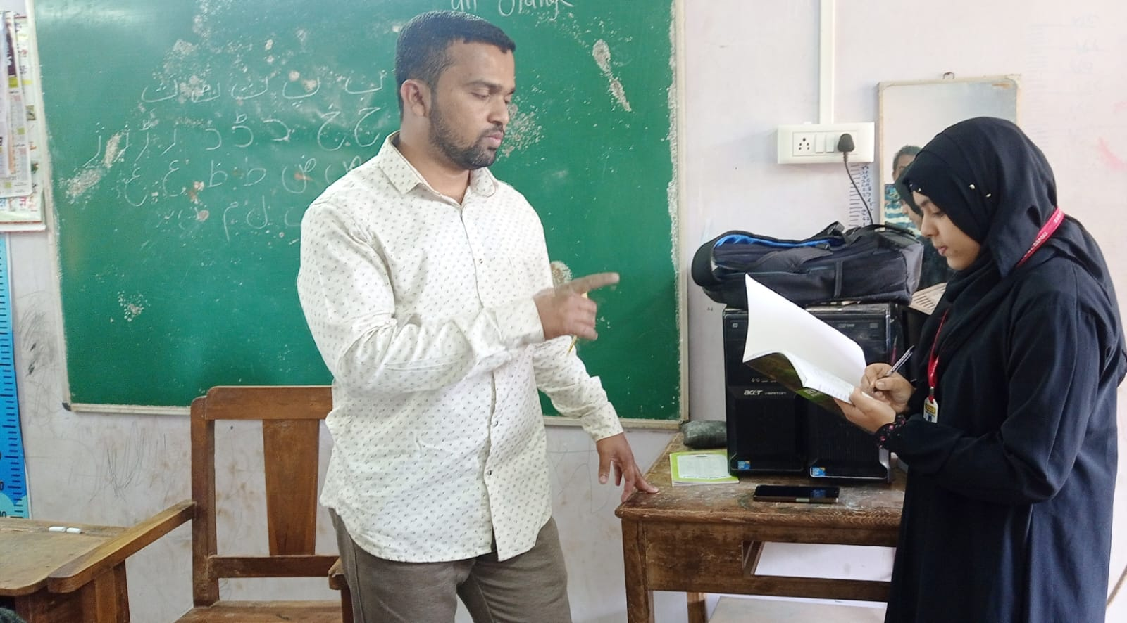
INTERVIEW OF TEACHER

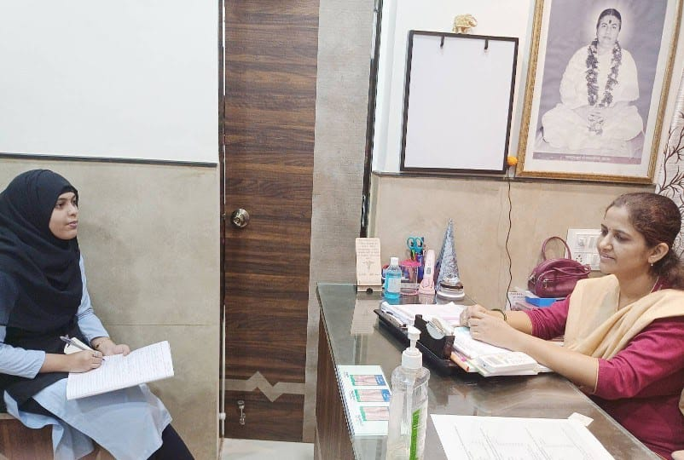
INTERVIEW OF DOCTOR
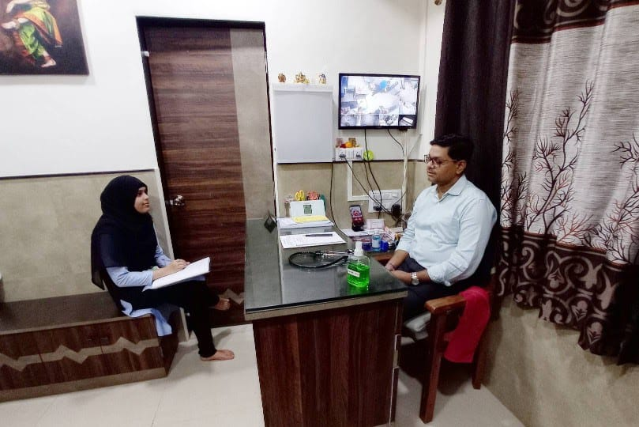
INTERVIEW OF C.A.

Activity: - Population Education Club (PEC)
- Aim:- To create the awareness about the social issues among the public by performing street play, rally ,etc.
- To bridge the knowledge gap between the College, University and the Community.
- No. of Participant:-13
- Date and Time: Through the year
- ACIVITIES
- Identified the problems in the society.
- Prepared and performed the street ‘Vinchu Chawala’ play on social problem.
- Poster competition and essay competition on that problems in schools .
- Awareness is also created through rally.

POPULATION EDUCATION PROJECT

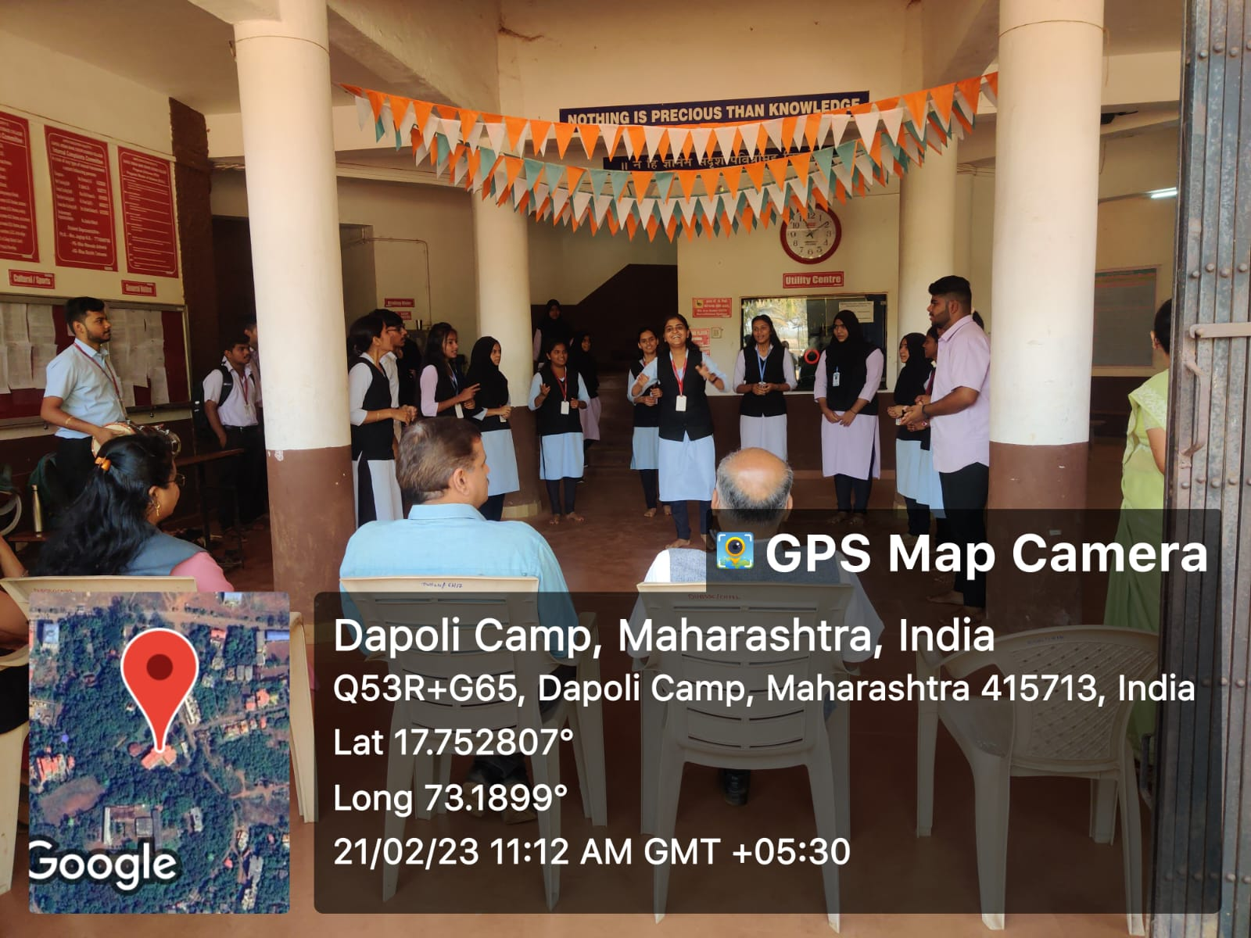
Street play at D.U.B. Senior Science College, Dapoli.
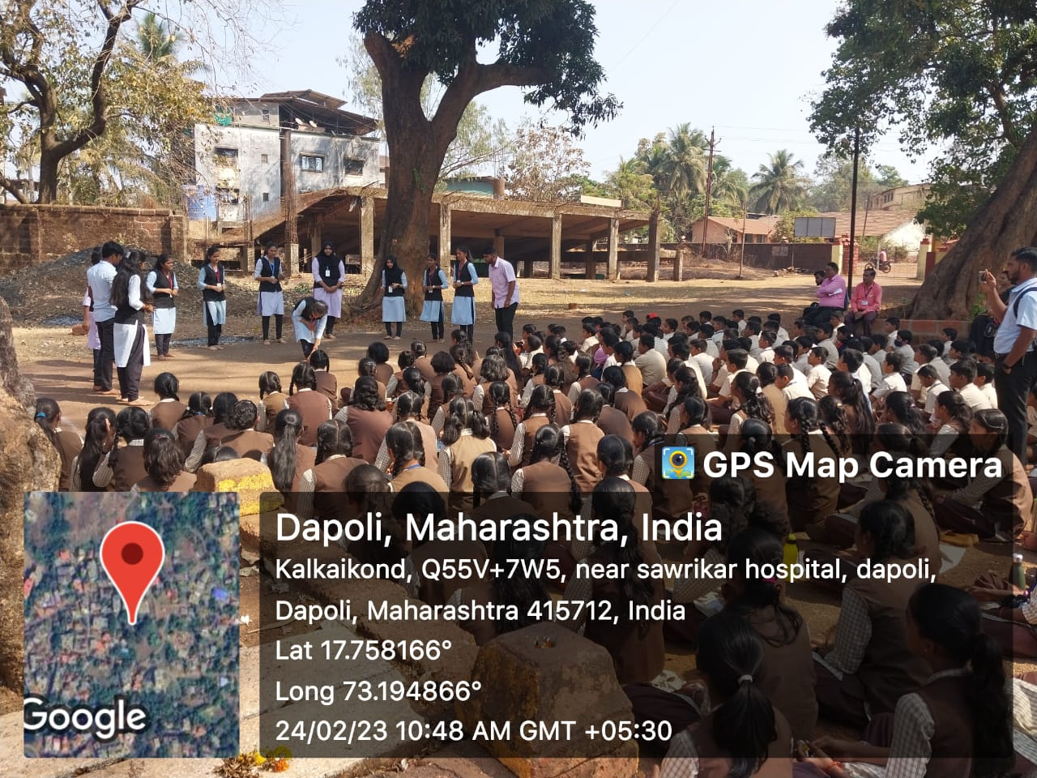
Street play at Dnyandeep Vidyamandir, Dapoli.

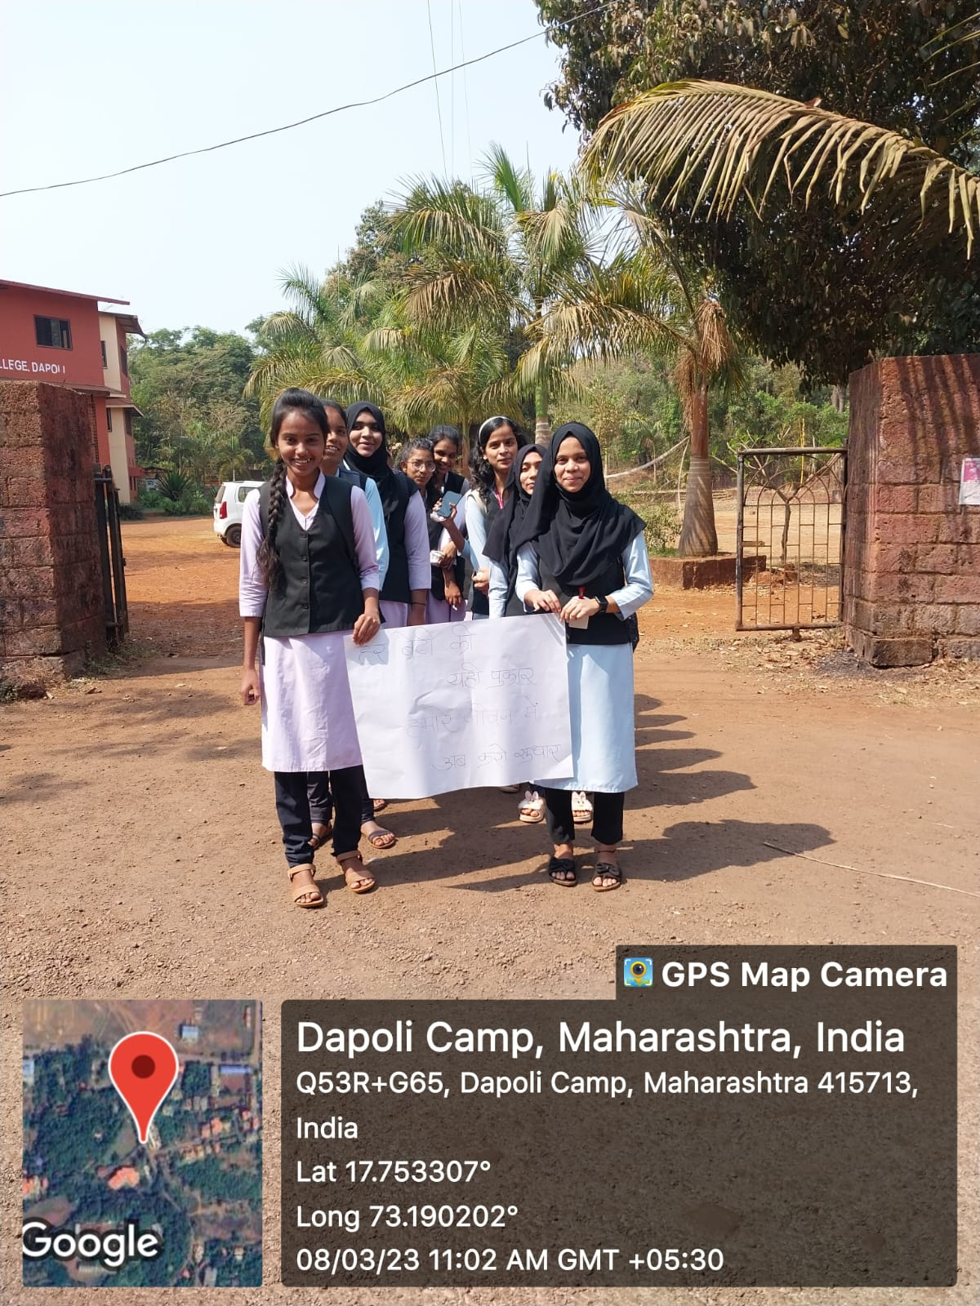
Rally of PEC project.

Activity report
- Name of the activity - First Term Training to Teachers and Students. (online mode )
- Aim –To give the information about all the project undertaken by the University
- Date–18/09/2022 Time- 1.00 pm-4.00pm
- No. of participants -42
- Overall conduct –DLLE conducted First Term Training to Teachers and Students. In this programme Dr. G.S.Gore gives the information about the different projects like APY, IOP, CP, SWS.etc
- Feedback – All students are satisfied

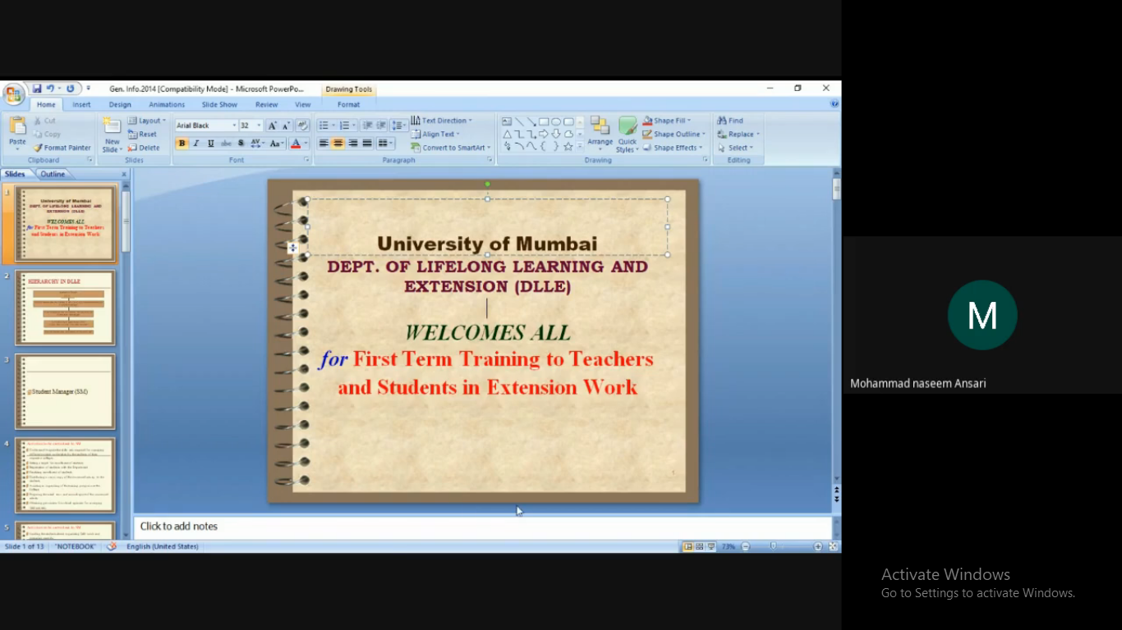

FIRST TERM TRAINING PROGRAMME.

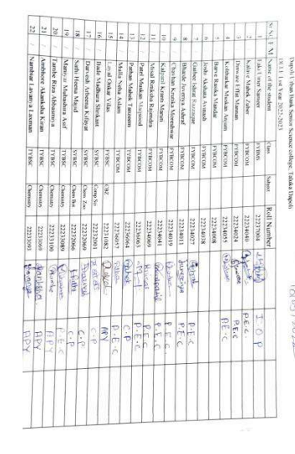

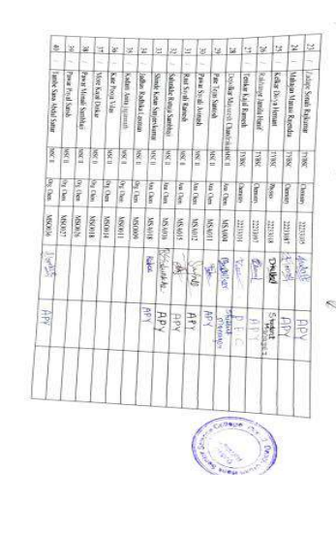

Activity report
- Name of the activity – Second Term Training to Teachers and Students.
- Aim –To give the information about Udaan Festival conducted by the University and review of work carried out in the first semester
- Date–05/12/2022
- Time- 2.30 pm-4.00pm
- No. of participants -46
- Overall conduct –DLLE conducted Second Term Training to Teachers and Students. In this programme Dr. G.S.Gore gives the information about the different projects like APY, IOP, CP, SWS.etc and Udaan Festival conducted by the University. Prof Shantanu Kadam , Prof. Neha Mundekar , Prof.Reshma Devrukhkar, Prof. Sujit Temkar took the review of all projects undertaken by the students.
- Feedback – All students are satisfied

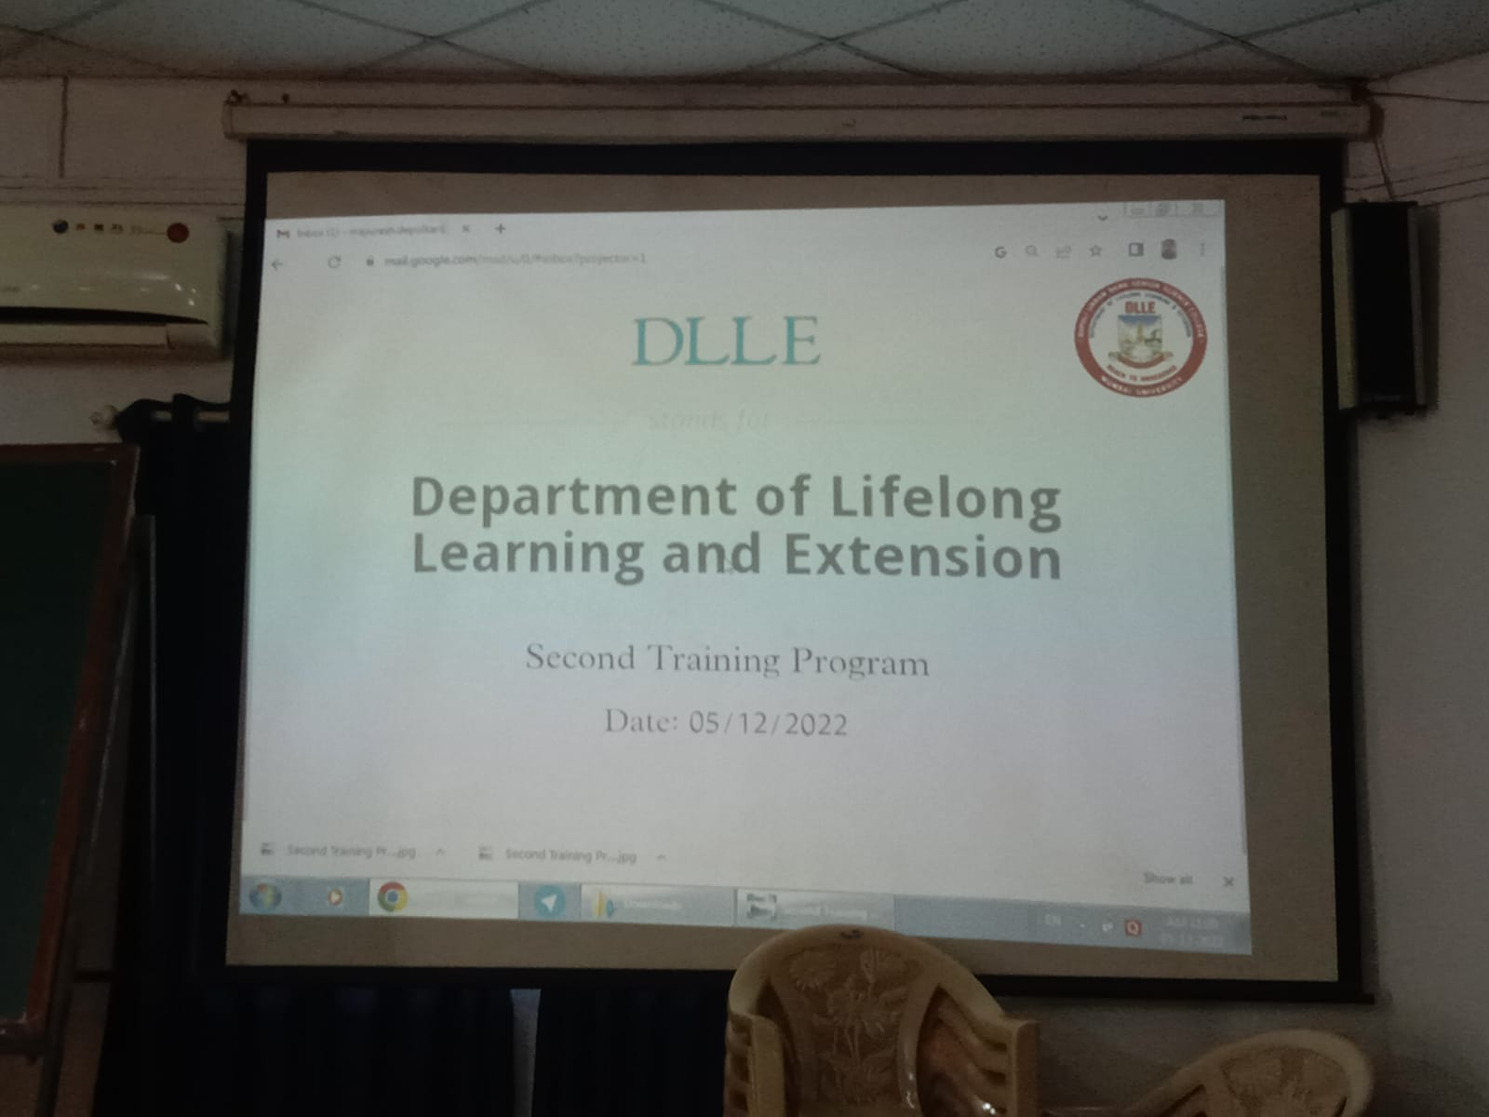
SECOND TERM TRAINING PROGRAMME.

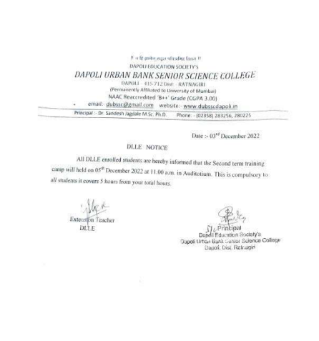

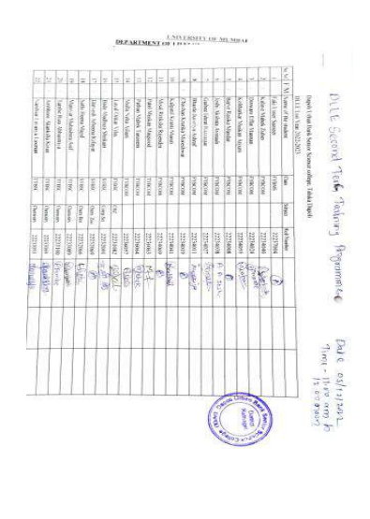

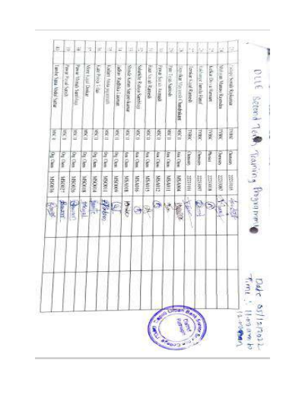

UDDAN FESTIVAL
Name of the activity –. UDDAN FESTIVAL

- Aim – To create awareness about the extension work done by the University of Mumbai through affiliated colleges in the community
.b) To create awareness about social issues through various competitions on extension work projects with the focus on College Youth.
c) To give opportunities to the students to enhance their skills to co-relate with the new avenues in the Field of Management, Education and Entrepreneurship, in this modern technological work
- Date–12/03/2022 Time- 9.00 am - 4.00 pm
- No. of participants -15
- Overall conduct – Department of Lifelong Learning and Extension organizes the Annual Extension Work Festival titled "UDAAN – the flight of Extension. In this program. This year, the Department will be organizing this Festival in an online mode and intends to invite all Extension Work colleges to participate in the festival. The Best Performances and Best Displays will be awarded the Udaan Certificate based on the recommendations of the panel of expert judges. The Organizing College, Field Co-coordinators, Extension Teachers and Anchors will also be felicitated with Special Contribution Certificate.
- The following Competitions will be organized in ONLINE MODE for Annual Festival
- “UDAAN: The Flight of Extension: 2022-2023”
- 1. Street Play (One entry each college)
- 2. Poster Competition (One poster each college.)
- 3. Powada singing (One Entry each college)
- 4. Elocution(One participant each college)
- 5. Creative Writing One participant each college)
- Dapoli Urban bank college, Dapoli participated in Street Play ,Poster , Powada singing, Elocution and Creative Writing Competition and achieved FIRST PRIZE in Street Play and elocution competition .

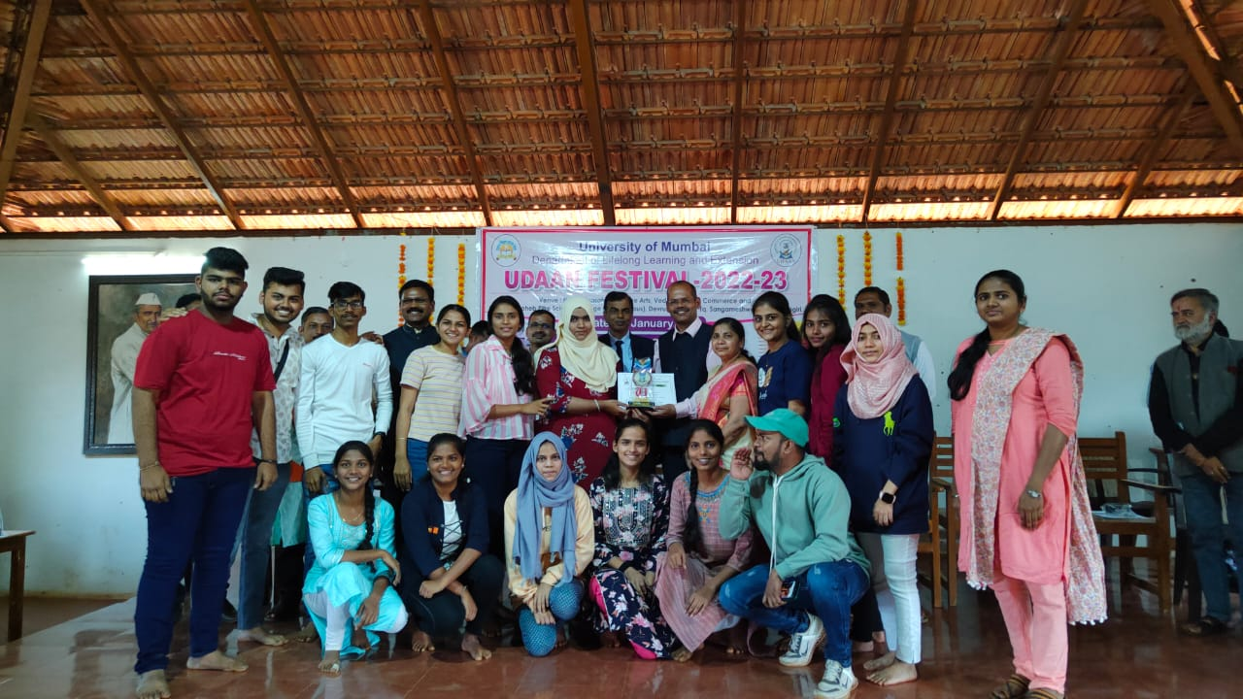
UNIVERSITY LEVEL FIRST PRIZE FOR STREET PLAY ‘VINCHU CHAWALA’IN UDDAN FESTIVAL

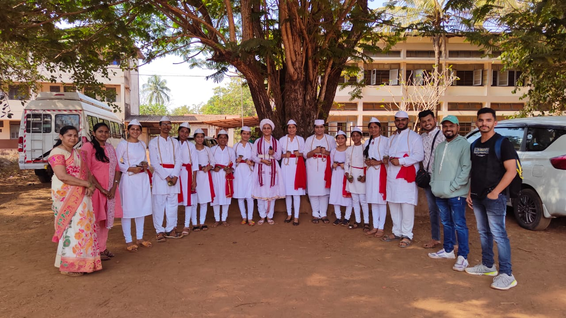
STREET PLAY ‘VINCHU CHAWALA’ AT DEVRUKH COLLEGE

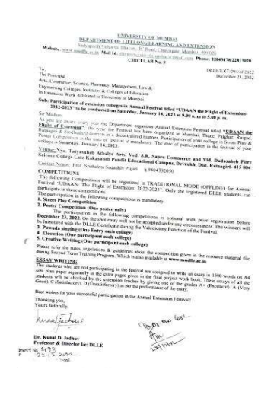

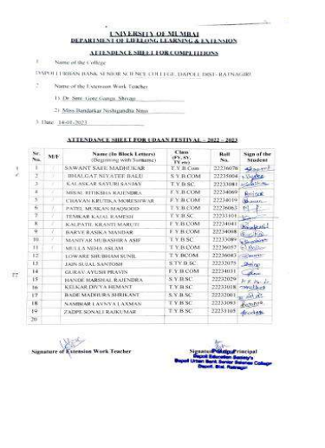

Activity report
- Name of the activity –Celebration of 75th Independence day
- Aim –To create awareness and proud about freedom of country
- Date–27/02/2023
- Time- 8.40 am
- No. of participants -256
- Overall conduct –DLLE conducted Celebration of 75th Independence day. In this programme Dr. S.P. Jagdale gives the information about the freedom of India.
- Feedback – All students are satisfied

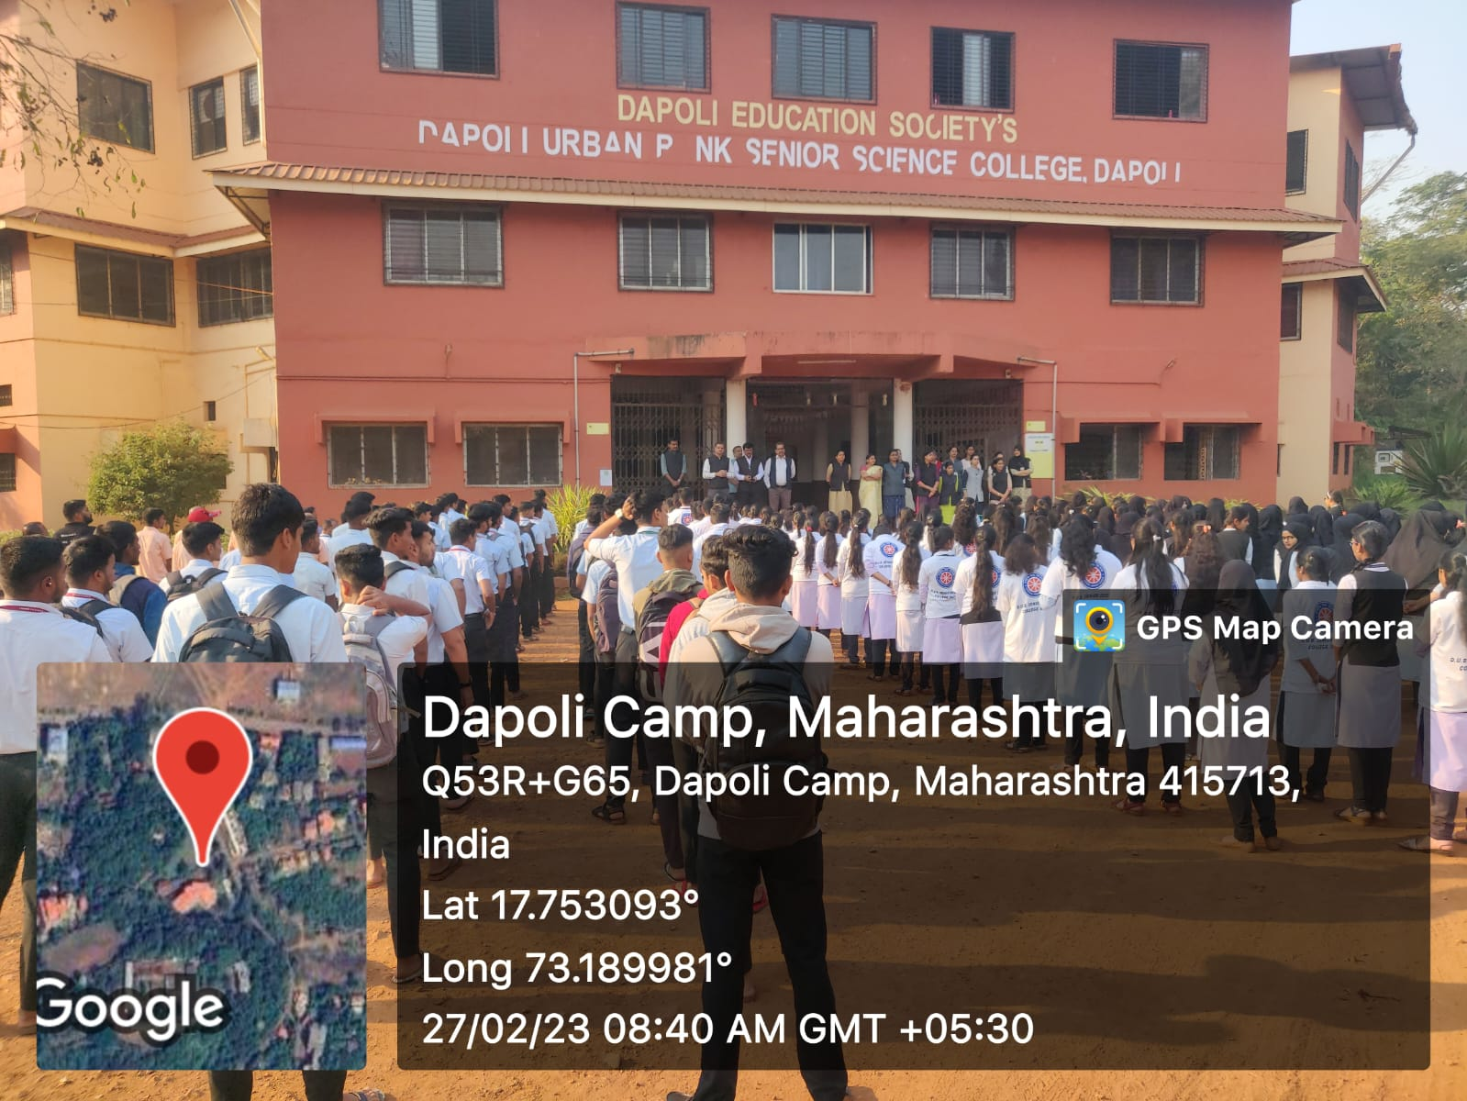

National Anthem conducted BY DLLE

