LIGO : LASER Interferometer Gravitational-Wave Observatory

A A Nandiskar and Diksha Lingayat (S.Y.B.Sc.)

Introduction:
LIGO, or the Laser Interferometer Gravitational-Wave Observatory, is a groundbreaking scientific project that has revolutionized our understanding of the universe.The history of LIGO can be traced back to the early 1960s, when Joseph Weber at the University of Maryland pioneered the effort to build detectors for gravitational waves. Weber's detectors were based on the principle of resonant bar detectors, which use large cylinders of aluminum that vibrate in response to a passing gravitational wave.
In 1962, Michael Gertsenshtein and Vladislav Pustovoit in Moscow, Russia, and independently several years later by Rainer Weiss in the United States, proposed a different approach to detecting gravitational waves using laser interferometry. In this approach, a laser beam is split into two beams that travel down two long, parallel arms of an interferometer. If a gravitational wave passes through the interferometer, it will cause the two arms to lengthen or shorten by a tiny amount, which can be detected by the laser beam.
History of LIGO:
The first laser interferometer gravitational wave detector was built by Rainer Weiss in the early 1970s. This detector was not sensitive enough to detect gravitational waves, but it paved the way for the development of more sensitive detectors.The Laser Interferometer Gravitational-Wave Observatory (LIGO) was conceived in the early 1980s by a team of scientists led by Rainer Weiss, Kip Thorne, and Ronald Drever. LIGO is a pair of laser interferometers located in Hanford, Washington, and Livingston, Louisiana. The two detectors are about 3,000 kilometers apart, which allows them to detect gravitational waves from different directions.Construction of LIGO began in 1994 and was completed in 2000. The first scientific observations with LIGO began in 2002, but no gravitational waves were detected. In 2008, LIGO began a major upgrade project called Advanced LIGO. The upgraded detectors began operation in 2015. LIGO consists of two observatories, one in Livingston, Louisiana, and the other in Hanford, Washington, both of which are designed to detect gravitational waves.

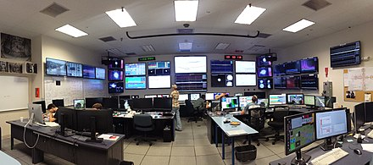
LIGO Livingston control room as it was during Advanced LIGO's first observing run

Construction of LIGO :
LIGO consists of two 4-kilometer-long vacuum tubes arranged in an L-shape. A laser beam is split into two beams that travel down the two arms of the interferometer. If a gravitational wave passes through the interferometer, it will cause the two arms to lengthen or shorten by a tiny amount, which can be detected by the laser beam.The construction of LIGO was a major undertaking. The vacuum tubes had to be built in underground tunnels to protect them from vibrations and other disturbances. The mirrors at the ends of the tubes had to be made of extremely smooth and stable materials. And the entire system had to be kept extremely cold to reduce the effects of thermal noise.
Here are some of the key components of LIGO:
- The vacuum tubes: The vacuum tubes are the heart of LIGO. They are 4 kilometers long and are made of ultra-pure steel. The tubes are kept under vacuum to reduce the effects of air resistance and other disturbances.
- The mirrors: The mirrors are located at the ends of the vacuum tubes. They are made of extremely smooth and stable materials, such as silicon carbide. The mirrors reflect the laser beam back and forth, allowing the interferometer to measure the slightest changes in the length of the arms.
- The laser: The laser is used to create the light beam that travels through the interferometer. The laser is very stable and produces a beam of light that is very narrow and intense.
- The control system: The control system monitors the performance of the interferometer and makes adjustments to keep it operating at its best. The control system also analyzes the data from the interferometer to look for signs of gravitational waves.

Gravitational waves are ripples in space-time caused by the acceleration of massive objects, such as the collision of two black holes or neutron stars. The effect of a propagating gravitational wave is to deform space in a quadrupolar form. The effect alternately elongates space in one direction while compressing space in an orthogonal direction and vice versa, with the frequency of the gravitational wave. A Michelson interferometer operating between freely suspended masses is ideally suited to detect these antisymmetric distortions of space induced by the gravitational waves; the strains are converted into changes in light intensity consequently to electrical signals via photo detectors.
Though Einstein predicted the existence of gravitational waves in 1916, the first proof of their existence didn't arrive until 1974, 20 years after his death. In that year, two astronomers, Russell Hulse and Joseph Taylor, using the Arecibo Radio Observatory in Puerto Rico discovered a binary pulsar 21000 light years from Earth. This was exactly the type of system that general relativity predicted should radiate gravitational waves. Knowing that the system could be studied to test Einstein's prediction, Taylor and two colleagues (Joel Weisberg and Lee Fowler) began tracking the radio emissions from the stars to measure how their orbital period changed over time.
After just four years, they first reported seeing a change in the period that verified that the stars were getting closer to each other at the rate predicted by general relativity (GR) if they were radiating gravitational waves (the rate predicted by GR agreed with the observed rate to within one half of one percent). In 1993, Hulse and Taylor would receive the Nobel Prize in Physics. These waves were first predicted by Albert Einstein's theory of general relativity in 1915 but remained elusive until the construction of LIGO.LIGO uses a sophisticated technique called laser interferometry to detect these waves. In simple terms, it works by splitting a laser beam into two perpendicular arms, bouncing them off mirrors, and then recombining them. When a gravitational wave passes through the observatory, it causes tiny, transient changes in the lengths of these arms, which are measured with incredible precision. This allows scientists to detect and analyse the gravitational waves produced by distant cosmic events.
Seismic motion causes forces on the mirrors due to the direct coupling through the isolation and suspension system, a technical noise source which is minimized through design; and due to the time-varying mass distribution near the mass (the Newtonian background).Sensing limitations arise most fundamentally due to the statistical nature of the laser light used in the interferometry, and the momentum transferred to the test masses by the photons (linking the sensing and stochastic noise limitations to sensitivity)
Achievements of LIGO:
The historic detection of gravitational waves by LIGO in 2015 confirmed a century-old prediction of Einstein's theory and opened a new era of astronomy. Since then, LIGO and its European counterpart, Virgo, have made numerous detections of gravitational waves, revealing a previously hidden side of the universe. These detections have provided insights into the nature of black holes, neutron stars, and the fundamental properties of gravity itself. They have also allowed astronomers to observe events that were previously invisible, such as the merger of black holes and neutron stars, shedding light on the most extreme and mysterious phenomena in the cosmos.
In addition to its scientific achievements, LIGO has been able to measure the spins of black holes involved in mergers. This information provides insights into the formation and evolution of black holes. LIGO's detection of the binary neutron star merger event, GW170817, was historic. It was the first time both gravitational waves and electromagnetic radiation (gamma-ray burst and optical light) were observed from the same astrophysical event. This event confirmed that neutron star mergers are responsible for the creation of heavy elements like gold and platinum. While the processes that generate gravitational waves are extremely violent and destructive, by the time the waves reach Earth they are thousands of billions of times smaller, diminishing over time and space just as the waves from a pebble dropped in a pond get smaller and smaller as they move away from the source. In fact, by the time gravitational waves from LIGO's first detection reached us, the amount of space-time wobbling they generated was a 1000 times smaller than the nucleus of an atom! LIGO was designed to make such inconceivable, exquisitely small measurements. LIGO has also played a crucial role in inspiring and educating the public about the wonders of the universe and the power of human curiosity and ingenuity.
LIGO and India:
The impact of LIGO in India is still unfolding, but it is clear that the project has the potential to make a significant contribution to science, technology, education, and international co-operation. LIGO-India is a joint project between India and the United States. The collaboration has already led to the establishment of several new research groups in India. It will be located in the Hingoli district of Maharashtra, about 450 km east of Mumbai. In April 2023, the Cabinet of India approved the project to build the advanced gravitational-wave detector in Maharashtra at an estimated cost of Rs 2,600 crore. The facility's construction is expected to be completed by 2030. It will be the fifth node of the planned network and will bring India into a prestigious international scientific experiment. These groups are working on a variety of projects related to gravitational wave astronomy, including the development of new detectors, the analysis of gravitational wave data, and the study of the astrophysical sources of gravitational waves. The collaboration between the two countries is expected to strengthen scientific ties and promote the exchange of ideas and technology.
LIGO-India is expected to have a positive impact on education in India. The project will provide opportunities for students and teachers to learn about gravitational waves and their importance. It will also help to raise awareness of science and engineering careers. The project is also expected to create jobs in the Indian economy. The construction and operation of the detector will require the skills of engineers, physicists, and other technical professionals. The project is also expected to generate demand for new products and services, such as software and instrumentation. Overall, the impact of LIGO-India in India is expected to be very positive. It will help to advance scientific research, promote technology development, improve education, and strengthen international collaboration.

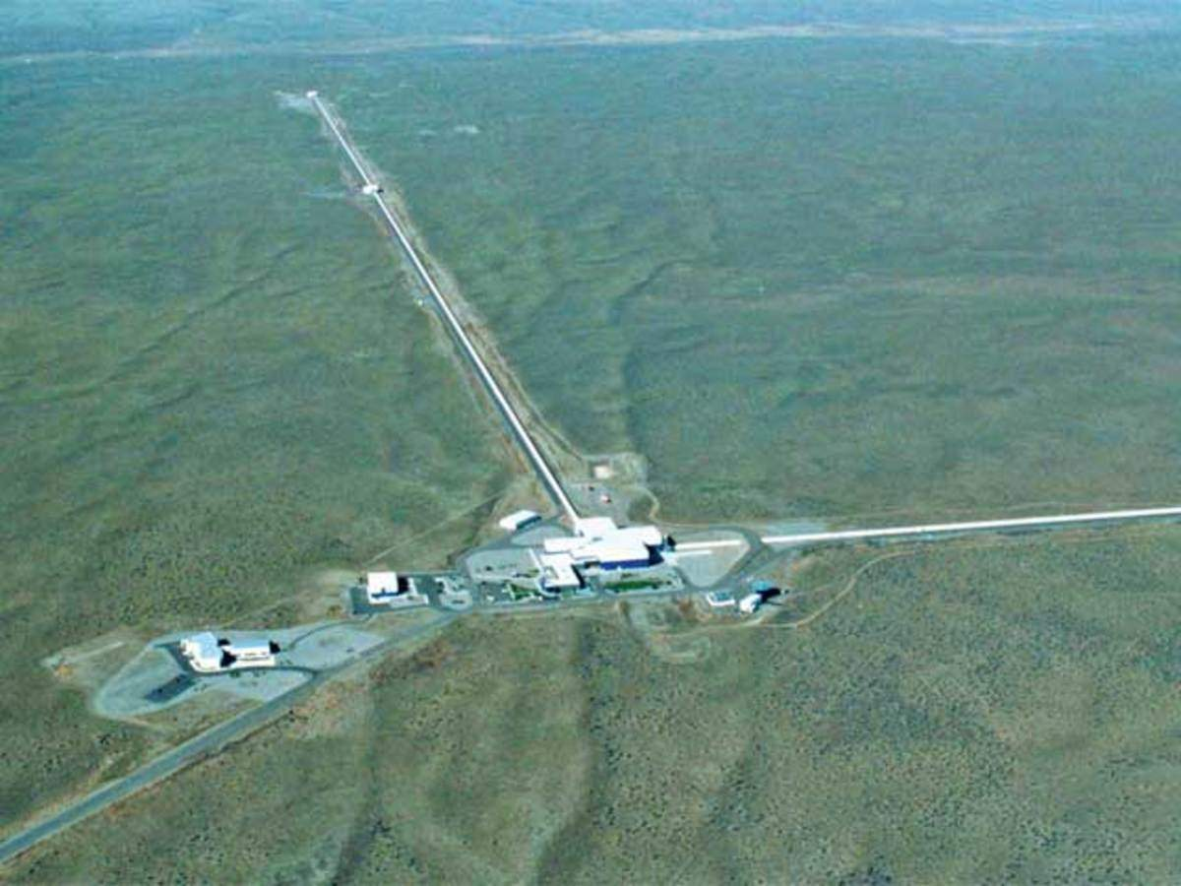
Maharashtra , India

Conclusion:
It is Funded by the National Science Foundation (NSF), LIGO was designed and constructed by a team of scientists from the California Institute of Technology, the Massachusetts Institute of Technology, and by industrial contractors. Construction of the facilities was completed in 1999. Initial operation of the detectors began in 2001. LIGO is still under development, and it is expected to become even more sensitive in the future. This will allow LIGO to detect even fainter gravitational waves from more distant sources. LIGO is also expected to be used to study the early universe and to search for new physics beyond the standard model. More generally, the scientific capability of LIGO is defined within the limits imposed by the physical settings of the interferometers and by the facility design, by the design of the initial detectors and ultimately by future interferometers designed to progressively exploit the facility capabilities.
Although the rates for gravitational wave sources have large uncertainty, an improvement in strain sensitivity linearly improves the distance searched for detectable sources. This increases the detection rate by the cube of the sensitivity improvement. The LIGO experiment is a remarkable achievement of human ingenuity and perseverance. It has opened a new window on the universe and has the potential to revolutionize our understanding of the cosmos. LIGO is a powerful tool for astronomy and astrophysics, and it is sure to make many more discoveries in the years to come. The LIGO experiment is a testament to the power of science and the human spirit. It is a reminder that anything is possible when people work together to achieve a common goal. LIGO will be used to delve into the fundamental nature of gravity, and as such will throw open an entirely new window onto the universe. Its observations will cross many borders and it will serve as an investigational tool for both physics and astronomy. In conclusion, LIGO is a remarkable scientific endeavour that has ushered in a new era of astrophysics by enabling the direct observation of gravitational waves. Its ground-breaking discoveries continue to reshape our understanding of the universe and push the boundaries of human knowledge.

References:

- https://advancedligo.mit.edu/summary.html
- https://en.m.wikipedia.org/wiki/LIGO
- https://www.drishtiias.com/daily-updates/daily-news-analysis/india-approves-construction-of-ligo
- https://www.thehindu.com/sci-tech/science/cabinet-ligo-india-approved-hingoli-construction-2030/article66709606.ece
- https://www.ipr.res.in/LIGO/

