Inter University Centre for Astronomy and Astro-physics IUCAA

Aniket A. Nandiskar Ayan Pathan (S.Y.B.Sc.)

IUCAA: Inter-University Centre for Astronomy and Astrophysics (IUCAA) is an autonomous institution set up by the University Grants Commission (UGC) of India to promote the nucleation and growth of active groups in astronomy and astrophysics at Indian universities. IUCAA aims to be a centre of excellence within the university sector for teaching, research and development in astronomy and astrophysics. 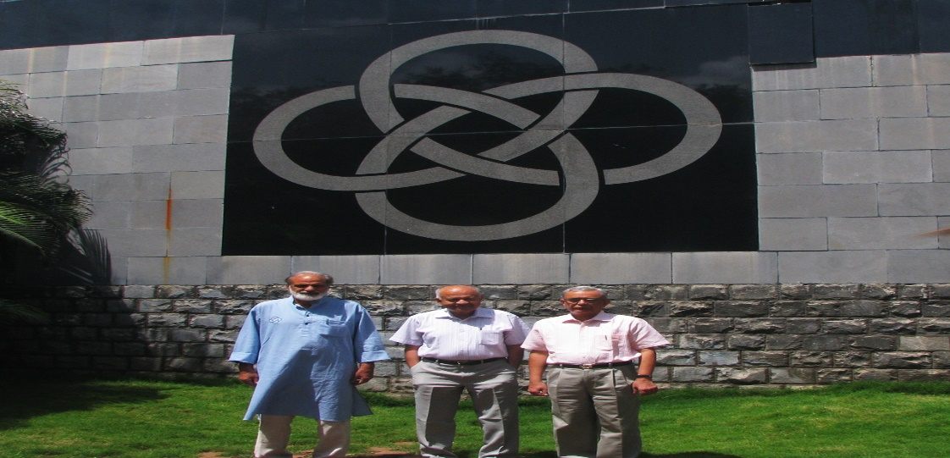

Organisation:
IUCAA’s activities fall under two broad programmes: core academic programmes and visitor academic programmes. Core academic programmes include basic research, the PhD programme, advanced research workshops and schools, the giant metre-wave radio telescope and guest observer programmes. Visitor programme, refresher courses for teachers and helping the nucleation and growth of astronomy and astrophysics at Indian university.
University Programmes IN IUCAA

Associateship Programme
- One important component of IUCAA's academic activities is the Associateship Programme, under which a faculty member of an Indian university or a post-graduate department in a college can visit IUCAA for periods of short and long durations over a span of three years to develop his or her interest and expertise in astronomy and astrophysics.
- The Associateship Programme has been designed to promote mobility and, to this end, the travel and local living expenses of an associate for these visits will be borne by IUCAA as per its rules. The associate will continue to carry out the existing commitments at his or her parent organisation. However, since IUCAA has been created by the UGC as a field station for these activities, it is expected that those visiting IUCAA under this programme will be treated as on duty by their respective organisations.
- Applications are invited for associateships for a tenure of three years, starting from August 1, every year.
- The selected candidates are usually informed by the end of July every year.

Refresher Course in Astronomy and Astrophysics
- IUCAA conducts a refresher course in Astronomy and Astrophysics for teachers at Indian universities and colleges for five weeks during the third week of May to the third week of June in every odd year (i.e., in 2017, 2019, 2021, 2023 and so on). The topics generally include observational and theoretical aspects of astronomy and state-of-the-art methods of data analysis. During the course there will be an emphasis on the use of computers for accessing and analyzing archival data.

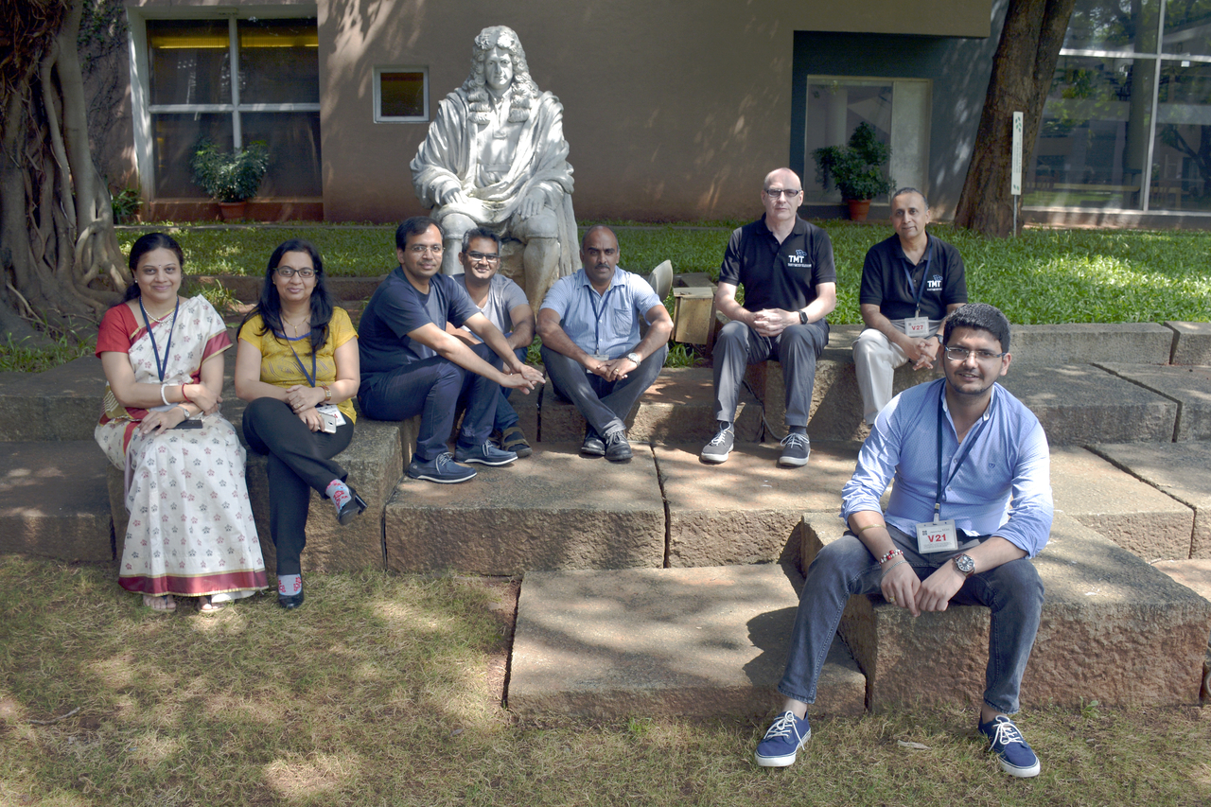

IUCAA Ph.D. Programme IN IUCAA

The intake of students into IUCAA's Ph.D. Programme is through
- IUCAA National Admission Test (INAT)
INAT is conducted by Inter-University Centre for Astronomy and Astrophysics, Pune. This test and the subsequent interviews are generally conducted in the first week of January every year at IUCAA Pune.
- Joint Entrance Screening Test (JEST)
This test is usually conducted at IUCAA, Pune, and at other centres in India on the third Sunday of February every year. For more details about JEST, test syllabus, sample question papers.
- CSIR-UGC NET for JRF (Physics)
Only those who have qualified for the Junior Research Fellowship (JRF) in the previous two years are eligible to apply. Those who have qualified for only Lecturership are NOT ELIGIBLE.
- Joint SPPU - IUCAA M.Sc. Physics (Astrophysics) Programme
The Inter-University Centre for Astronomy and Astrophysics (IUCAA) and the Savitribai Phule Pune University (SPPU) announce a joint M.Sc. programme in Physics (Astrophysics), having recognized a growing need for broadly trained students to work on large astronomy/astrophysics projects such as LIGO-India, TMT, SKA, space-based astronomy missions, etc. within the country. This programme is envisaged to be a flagship Masters' programme to prepare students to undertake research in contemporary astronomy and astrophysics. The M.Sc. programme will provide the requisite training in physics and astrophysics through theoretical physics and astrophysics courses, experimental, observational, and computational work, and projects on current research topics.

IUCAA M.Sc. Teaching
IUCAA offers neither a B.Sc. in Astronomy nor an M.Sc. in Astronomy. However, IUCAA faculty are involved in teaching the Astronomy and Astrophysics, Papers I and II of the third and fourth semesters of the M.Sc. programme in Physics at the University of Pune. Astronomy and Astrophysics is an optional course for M.Sc. (Physics) students. Normally, about 10 students are admitted to this course. (Admission to the course is done by the Department of Physics, University of Pune) The syllabus for these courses is given below.
- IUCAA Student Projects
IUCAA offers the opportunity for local students in the Pune area to work on projects of varying durations. Interested students are invited to contact faculty directly. Students outside Pune are encouraged to apply for the summer school programme or the vacation students' programme.
Limited number of students studying in B.Sc. / B.E. / B.Tech. / M.Sc. / M.E. / M.Tech. are admitted in IUCAA to do their projects in Astronomy and Astrophysics or related topics. These students should have thorough basics in Physics and Mathematics. Once they are admitted, they will be supervised and guided by one of the IUCAA faculty members. They may be asked to attend lectures and complete a few assignments. These projects may be for a short period of less than three months or long period of more than three months, but less than one year.
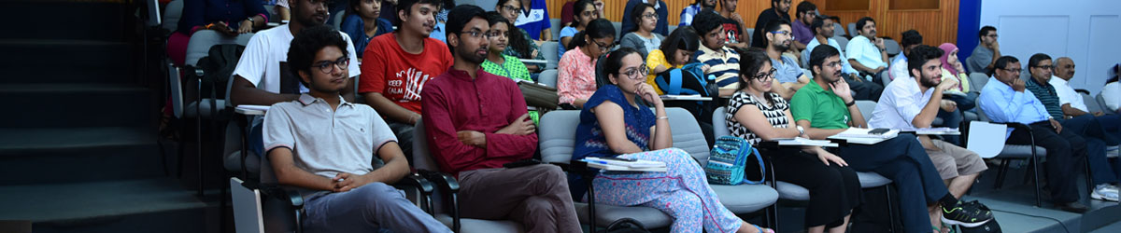

The students have to be recommended by their supervisor/head of the department. They have to apply in plain papers, giving their complete curriculum vitae, and a short write up regarding their interest in the project.
For outstation and local candidates, the support (like travel, local hospitality, honorarium, etc.) to be given by IUCAA is to be decided.
At the end of the project, the students have to prepare a report and submit it to the IUCAA supervisor, which will be evaluated, and the outcome will be informed to their respective supervisor / head of the department.
Research at IUCAA spans a wide range of fields. Current areas of active research include
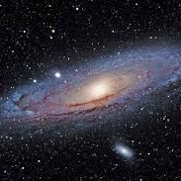
Cosmic Magnetic Fields
The universe is magnetized. The earth, Sun, Galaxies, Galaxy clusters all host coherent magnetic fields and perhaps even the intergalactic medium in large-scale voids. How do these systems get magnetized? The standard picture involves turbulent dynamo amplification of a weak seed magnetic field. The seed could arise in a cosmic battery and cosmic dynamos then convert kinetic energy of motions to magnetic energy. The processes involved in generation and maintaining of magnetic fields has been the focus of several IUCAA research

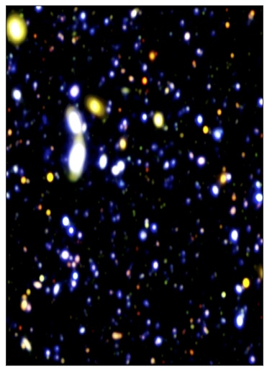

Extragalactic Astronomy
- IGM: Most of the bayrons created in the Big bang reside in regions between galaxies. These regions are called Intergalactic medium (IGM). Absorption lines imprinted in the spectra of distant bright objects such as quasars or Gamma ray bursts allow us to probe the physics of the IGM and its redshift evolution. In particular the astronomers at IUCAA have made important contributions to this field such as: (1) Measuring the HI photoionization rate as at low-z, (2) Computing consistent UV background as a function of redshift, (3) Constraining the UV escape fraction from star forming galaxies, (4) Accurately measuring the thermal evolution of the IGM that allow one to probe the physical condition during He II reionization, (5) First measurement of redshift space three-point correlation function at low-z, (6) Accurate measurement of redshift evolution of two- and three-point correlation function (7) large survey of OVI at high-z (8) accurate modeling of metal line absorbers and (9) heating of the IGM using cosmic rays.
- Galaxy evolution: Galaxies, primarily made up of stars, gas and invisible dark matter, are the fundamental building blocks of our universe. When and how these galaxies have formed remain as one of the outstanding challenges in modern astronomy. The challenges arise because galaxies are not isolated systems like “Island universes”; they are highly interacting, they merge with another, accrete gas/satellites from surrounding or the cosmic web.

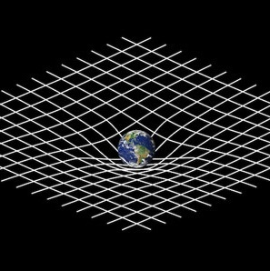
Instrumentation for Astronomy
The laboratory is involved in developing a number of science instruments for astronomy applications from ground and space. New technologies are also developed as part of R&D activities including the use of optical fibres for 2D spectroscopy, sensor electronics, adaptive optics systems etc. The instrument and technology development programmes are integrated into several national and international collaborative projects
(Note: There are many other current active researches going on including cosmology and large scale structure, computation astrophysics ,Gravitational lensing ,Gravitational waves ,high energy astrophysics, mega science ,solar and stellar physics and last the quantum metrology and precision measurements)

History of IUCAA
IUCAA as a research institute, is looked upon by all as a place where Science is applied in an exciting field. SciPoP is an uniquely started effort towards increasing public awareness and understanding of Science & Astronomy. It is aimed at making people aware of the importance of Science education as well as to getting students genuinely interested in Science and motivated towards taking up a research career towards its advancement.
Science plays an important role in everyone's life. SciPOP was set up over two decades ago with the vision of Prof. Jayant V. Narlikar to make the common man aware of this. Initially Late Prof. Narayan. C. Rana and Mr. Arvind Paranjpye actively looked after the programme. Under the supervision of Prof. Somak Raychoudhary the Science Park was added to the resources.
In 2004, we got our own campus - the Muktangan Vindyan Shodhika (MVS) - when the Pulastya building was built with a generous donation from Smt. Sunitabai Deshpande.
Scipop now has local, national and international repute in a wide variety of roles and activities in science popularisation, in addition to the regular outreach of the institute's Astronomy and Astrophysics research.
IUCAA Resources
- Observational Facilities
Links to pages for various observational facilities of IUCAA.
- IUCAA Girawali Observatory (IGO)
- Southern African Large Telescope (SALT)
- Other National Facilities : AstroSat
- Astrosat Science Support Cell (ASSC)
- Laboratories
IUCAA has a dedicated High Performance Computing centre, a Radio Physics lab for training students and an instrumentation lab with cutting edge technology for development of astronomy instrumentation. Explore links below for more details.
- High Performance Computing
- High Performance Computing - SARATHI
- IUCAA Radio Physics Lab
- Instrumentation Laboratory
- Precision & Quantum Measurement laboratory (PQM-lab)
- Library Facilities
Links to various online services of the IUCAA library.
- Library Online Catalogue
- Library e-Resources
- Remotlog (off-campus access)
- AEC (YouTube)
- Institutional Archives
- Library Blog
- Astronomy Talks
- Virtual Observatory India
The Virtual Observatory India project is a collaboration between two participating institutes. i.e. Inter-University Centre for Astronomy and Astrophysics (IUCAA) and Persistent Systems Ltd., Pune. This project is supported by the Ministry of Communication and Information Technology, Government of India.
- Astronomical Data Archives
IUCAA hosts a NASA Astrophysical Data System mirror.
- Astrophysical Data System (ADS)
- arXiv
- Catalina Real-Time Transient Survey (CRTS)
- Chandra Archive
- VIZIER Catalogue Service
- INSPIRE
- IUCAA Periodicals / Bulletins
For current and old issues of various IUCAA periodical publications.
- Annual Report Archive
- Khagol Issues
- VYOM Issues

- Events at IUCAA 2022 - 23
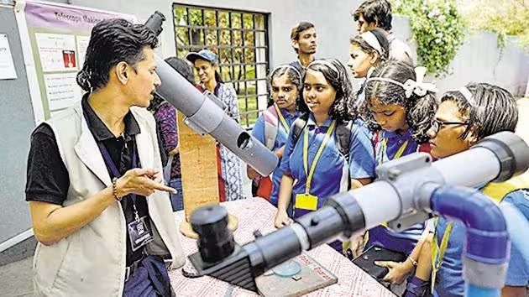
- Annual Events at IUCAA 2022 - 23
- Foundation Day. Date: December 29, 2022.
- National Science Day. Date: February 26, 2023.
- Refresher Course on Astronomy and Astrophysics. Date: May 15 - June 16, 2023.
- Introductory Summer School on Astronomy and Astrophysics. Date: May 15 - June 16, 2023.
- Vacation Students' Programme. Date: TBD.
- Public event at IUCAA
- Science Toys Activity
- Sky Watching
- Campus Visits
- Events Outside IUCAA 2022 - 23
- Introductory workshop on Active Galaxies
- High energy emission from Active Galactic Nuclei
- Workshop on UVIT Data Analysis on Galaxies
- Seminar on Current Status of Cosmology

- REFERENCE:

- https://www.iucaa.in
- https://inat.iucaa.in

