Indian Institute Of Technology.
D.D.Kulkarni and Shraddha S.Shinde (F.YB.Sc.)
HISTORY
After the end of the Second World War and before India got independence, Sir Ardeshir Dalal from the Viceroy’s Executive Council foresaw that the future prosperity of India would depend on technology. Therefore he conceptualized institutes that would train such work forces in the country itself. This is considered to be the first conceptualization of the Indian Institutes of Technology.

Dr. Humayun Kabir played an important role in establishing IITs. He encouraged Dr B. C. Roy, the Chief Minister of West Bengal to work on Sir Ardeshir’s proposal for a IIT. In 1945, Dr Kabir along with Sir Jogendra Singh of the Viceroy’s Executive Council (Department of Education, Health and Agriculture) set up a 22 member committee to prepare a proposal, and made Sir Nalini Ranjan Sarkar the chairman. The Sarkar Committee recommended in 1945 that at least four Higher Technical Institutes on the lines of famous Massachusetts Institute of Technology, U.S.A. be established in the Eastern, Western, Northern and Southern regions of the country.

Post Independence, it was Pandit Jawaharlal Nehru who pioneered establishing of the Indian Institutes of Technology to provide trained technical personnel of international class to the nation who would act as leaders in technology for the newly born independent India. Nehru, being an enthusiast and patron of science, was clear that science and technology had a prominent role to play in modernizing India and meeting the needs of its growing population. He envisioned that the IIT system would over time provide scientists and technologists of the highest caliber who would engage in research, design and development to help building the nation towards self-reliance in her technological needs.
The Institutions were to be designed with the necessary dynamism, flexibility of organization and capacity to adapt in the light of expanding knowledge and changes in the socio-economic requirements of modern society. In May 1950, the first in the series was established in Kharagpur at the site of the Hijli Detention Camp, where the British had incarcerated political prisoners; the institution was named the “ Indian Institute of Technology” before its formal inauguration on August 18, 1951. Within a decade of the launch of the first IIT, four more were set up: IIT Bombay (1958), IIT Madras (1959), IIT Kanpur (1959), and IIT Delhi (1961). Decades later, the sixth IIT was established in Guwahati (1994). India’s first technical institute, set up in 1847 and known as the Thomson College of Engineering and subsequently the University of Roorkee, was ordained as the seventh IIT in September 2001. In the year 2008, six new IITs were started: IIT Bhubaneswar, IIT Gandhinagar, IIT Hyderabad, IIT Patna, IIT Rajasthan, and IIT Ropar. This was followed by two more IITs in 2009: IIT Indore and IIT Mandi. During the early years, the IITs benefited in varying degrees from material assistance and academic cooperation from developed countries — IIT Bombay from the Soviet Union, IIT Madras from Germany, IIT Kanpur from the United States, and IIT Delhi from the United Kingdom.
Over the years IITs have created world class educational platforms dynamically sustained through internationally recognized research based on excellent infrastructural facilities. The faculty and alumni of IITs have made huge impact in all sectors of society, both in India and abroad. The institutes are globally recognized as centres of academic excellence, and are reputed for the outstanding calibre of the students graduating from them.
Contact
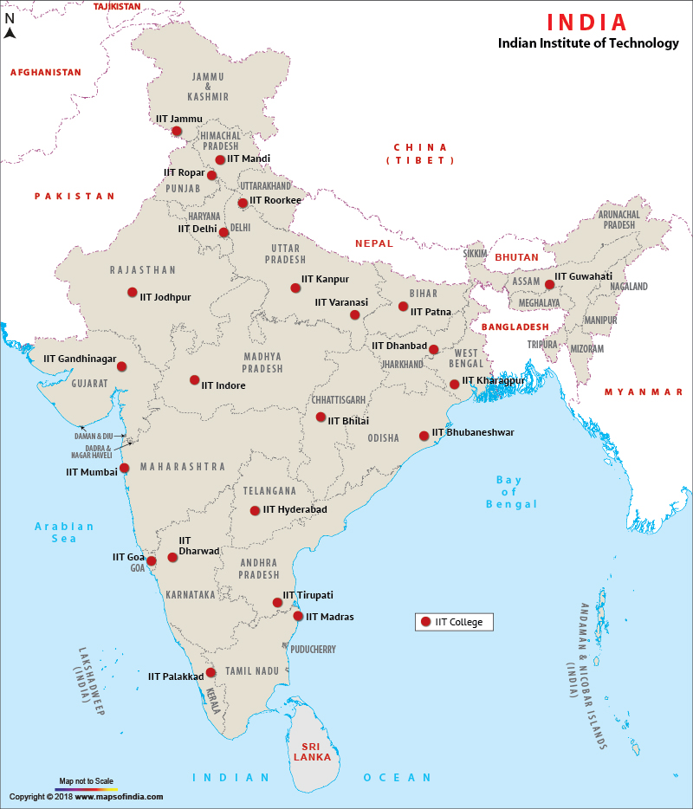
IIT System
iitcouncilweb@iitk.ac.in

What is IIT?
The Indian Institute of Technology (IITs) is a government-owned conglomerate of educational institutions in India.The Indian Institute of Technology (IIT system) are an autonomous educational institution governed by a board of directors. It is established to set create world-class scientists, engineers and technologists.These institutes of national importance increased industrial development and manufacturing by using the engineering expertise of the country.
1.Total IIT in India
There are 23 total IITs in India. The IITs are autonomous engineering Institutes governed by a board of directors.
2.IIT COURSES
The Indian Institutes of Technology ( IITs) offer various undergraduate programmes (UG), postgraduate (PG) and doctorate (PhD)levels in Science, Engineering and Technology.
IITs in India together offer over 250 Bachelor of Technology (B.Tech) programmes.
The IIT Courses: IITs offer degree programmes – B.Tech, M.Tech and Dual Degree (B.Tech-M.Tech). However, they also offer degree courses in B.Arch, M.Arch and BSc etc.
Here is a complete list of popular courses offered by 23 Indian Institutes of Technology (IITs) across India. Visit the link here for complete information about popular IIT courses in India.
References:-

