Indian Institutes of Science Education and Research (IISERs)

Digambar D.Kulkarni. and Miss Sakshi S. Pawar (F.Y.B.Sc.).

•Introduction:
Indian Institutes of Science Education and Research (IISERs) were established in 2006 through a proclamation of the Ministry of Education, Government of India to promote quality collegiate education and research in basic sciences.
•History:
The government accepted the recommenda- tions and IISERs were set up in Kolkata and Pune in 2006. Soon followed IISERs in Mohali (2007), Bhopal (2008) and Thiruvananthapuram (2008). A few years later, two more IISERs were set up, one in Tirupati (2015) and another in Berhampur (2016).
1.Indian Institute of Science Education and Research (IISER), Kolkata
IISER Kolkata was established inAugust 2006. The central theme of the IISER –K is to integrate education With research so that undergraduate teaching as well as doctoral and postdoctoral research work could be carried out in symbiosis.
IISER Kolkata offers BS-MS dual degree, MS degree, Integrated PhD , PhD.4
For more details, click here: http://www.iiserkol.ac.in/
2. Indian Institute of Science Education and Research (IISER), Pune
The Indian Institute of Science Education and Research Pune is a premier institute dedicated to research and Teaching in the basic sciences was established in 2006.Integrated Masters (M.S.) program aims to integrate the conventional bachelors and masters programs into a more holistic science education experience, bringing together conventional disciplines in the biological,Chemical, mathematical and physical sciences. The program focuses on the unified nature of science and aims to train some of the brightest young minds of our country, through some of the best practitioners of science in India.
IISER Pune offers BS–MS dual degree, Masters’, PhD and Integrated PhD.
For more details, click here: http://www.iiserpune.ac.in/
3. Indian Institute of Science Education and Research (IISER), Mohali
The Indian Institute of Science Education & Research (IISER) Mohali has been established as an autonomous Academic institution in 2007, to carry out research in frontier areas of science and provide quality science Education at the undergraduate and postgraduate level. The broad focus of IISER Mohali is to integrate Excellence in scientific research with education.The academic activity of IISER Mohali is interdisciplinary in nature, with a focus on the basic sciences. The Emphasis is on expanding the frontiers of knowledge while focusing on the fundamentals of science. IISER Mohali’s major thrust areas are: PhysicalSciences, Chemical Sciences, Life Sciences, Mathematics & Computer Science, Material Science and Environment & Earth System Science.
IISER Mohali offers BS-MS dual degree, Integrated PhD, PhD.
For more details, click here: http://www.iisermohali.ac.in/
4. Indian Institute of Science Education and Research (IISER), Bhopal
The Indian Institute of Science Education & Research (IISER) Bhopal was established in 2008, with a mission to provide high quality science education to Undergraduate and post-graduate students. The prime focus is to integrate science education and research with a motive of attracting bright students and world class faculties.
IISER Bhopal offers the BS, BS-MS dual degree, MSc/MS, Integrated PhD, PhD.
For more details, click here: http://www.iiserbhopal.ac.in/
5. Indian Institute of Science Education and Research (IISER), Thiruvananthapuram
The Indian Institute of Science Education & Research (IISER) Thiruvananthapuram was established inAugust 2008, and is dedicated to scientific research and science education of international standards.
IISER TVM offers BS-MS dual degree, MSc, Integrated PhD and PhD.
For more details, click here: http://www.iisertvm.ac.in/
6. Indian Institute of Science Education and Research (IISER), Tirupati
The Indian Institute of Science Education & Research (IISER) Tirupati was established in 2015, and is dedicated to scientific research and science education of international standards.
IISER Tirupati offers BS-MS dual degree, Integrated Ph.D. and PhD.
For more details, click here: http://www.iisertirupati.ac.in/
7. Indian Institute of Science Education and Research (IISER), Berhampur
The Indian Institute of Science Education and Research Berhampur, established in 2016 by the Ministry of Education, Government of India is a Centerof Excellence dedicated to teaching and research in basic sciences. As a unique initiative in science education in India, IISER Berhampur aims to be a University of the highest Caliber devoted to both high quality teaching and state-of-the-art research ina totally integrated manner, thus Nurturing both curiosity and creativity.
IISER Berhampur offers BS-MS dual degree, Integrated PhD and PhD.
For more details, click here: http://www.iiserbpr.ac.in/
•IISER Famous for :IISER is well known for its five year dual degree programmes BS-MS. It is also popular for giving opportunities to undergraduate students to undertake research and experiments unlike other institutions where only postgraduate candidates are given this chance.
•Mission and Vision :The basic idea of IISER is to create research Universities of the highest calibre in which teaching and education Will be totally integrated with the state of the art research. These Universities are devoted to Undergraduate and Postgraduate teaching in sciences in an intellectually vibrant atmosphere of research. One of the important Objectives of creating these Universities is to make education and careers in basic sciences more attractive by Providing opportunities in integrative teaching and learning of sciences and break the barriers of traditional Disciplines.
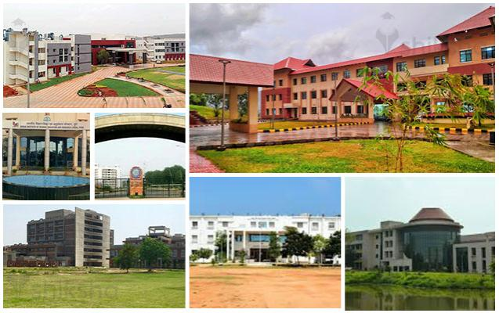
•Projects and other facilities :Sponsored Projects and Consultancy :IISER Kolkata considers sponsored research with utmost importance. Additionally, the consultancy projects to be undertaken by the faculty members will be very much appreciated. The R&D office will coordinate various aspects of project management, like initiation of project proposal,Opening an account in the R&D Office, hiring of project personnel, purchase,etc .
Indian Institutes of Science Education and Research (IISERs)

