HOMI BABA INSTITUTE
Vishwesh R. Joshi A. H. A.Chimawkar
Class:-FYB.Sc (Roll No:-23241024)
INTRODUCTION
The Homi Bhabha National Institute (HBNI) was established in 2005 under section 3 of the UGC Act. HBNI has the following Centres as its Constituent Institution (CI)/Off-Campus Centre (OCC): The Homi Bhabha National Institute (HBNI) was established in 2005 under section 3 of the UGC Act. The role of HBNI is to nurture in-depth capabilities in nuclear science and engineering and to serve as a catalyst to accelerate the pace of basic research and facilitate its translation into technology development and applications through academic programs, viz., Master's and Ph.D. degrees in Engineering, Physical, Chemical, Mathematical, Life and Medical & Health Sciences while encouraging inter-disciplinary research. Additionally, academic programs in the domain of Applied Systems Analysis have also been identified to ensure the availability of adequate qualified human resources to address issues pertaining to nuclear law, the economics of nuclear power, nuclear security, nuclear proliferation, intellectual property rights etc. HBNI has been accredited by NAAC with a score of 3.4, as a category 'A+' University in 2021. In the MHRD's National Institutional Ranking Framework (NIRF) exercise for the academic year the 2022, HBNI received 17th rank in the University, 15th position in Research Institution category and was placed at 30th position among 1657 institutions in the overall category. HBNI has the following Centres as its Constituent Institutions (CI’s)/Off-Campus Centre (OCC):perty rights etc. HBNI received among 1657 institutions in the overall category.
HISTORY
The Indian Department of Atomic Energy (DAE) was set up in 1954 and its mandate includes research including fundamental research in matters connected with atomic energy and the development of its uses in power generation, research, agriculture, industry and health care and advancement of higher mathematics. In pursuit of its mandate DAE has established several research and development centres, grant-in-aid institutions and has taken in its fold several existing grant-in-aid institutions. All research institutions under the umbrella of the DAE have been pursuing academic programme right from their inception. Considering continued expansion of atomic energy programme and considering the fact that the DAE institutions are engaged in human resource development programmes, the DAE Science Research Council recommended in 2003 that the DAE should establish a university-level institution. After completing all formalities, Prime minister of India, Manmohan Singh, announced the approval of the government of India for setting up of HBNI on 4 June 2005. It is named after the late Indian physicist Homi J. Bhabha. The HRD Ministry of the government of India declared Homi Bhabha National Institute (HBNI) a deemed to be university along with ten Constituent Institutions (CIs).
The first director/vice-chancellor, Ravi Grover has written a brief history of the institute in an article published by him on the website of the Indian National Academy of Engineering. He has also written an article in Current Science (10 October 2019) explaining the rationale for setting up the institute.
For developing a well trained central government engineers in the area of nuclear science and engineering, DAE established the "Training School" in 1957 at Trombay, Mumbai. Courses are conducted at all CIs and at BARC Training schools
AFFILIATED INSTITUTE
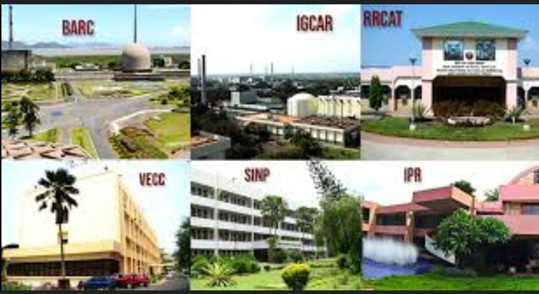
i. Bhabha Atomic Research Centre (BARC), Mumbai
ii. Indira Gandhi Centre for Atomic Research (IGCAR), Kalpakkam
iii. Raja Ramanna Centre for Advanced Technology(RRCAT), Indore
iv. Variable Energy Cyclotron Centre (VECC), Kolkata
v. Saha Institute of Nuclear Physics (SINP), Kolkata
vi Institute for Plasma Research (IPR), Gandhinagar
vii. Institute of Physics (IoP), Bhubaneswar
viii Harish-Chandra Research Institute (HRI), Allahabad
ix. Institute of Mathematical Sciences (IMSc), Chennai
x. Tata Memorial Centre (TMC), Mumbai
xi. National Institute of Science Education and Research (NISER), Bhubaneswar (OCC)
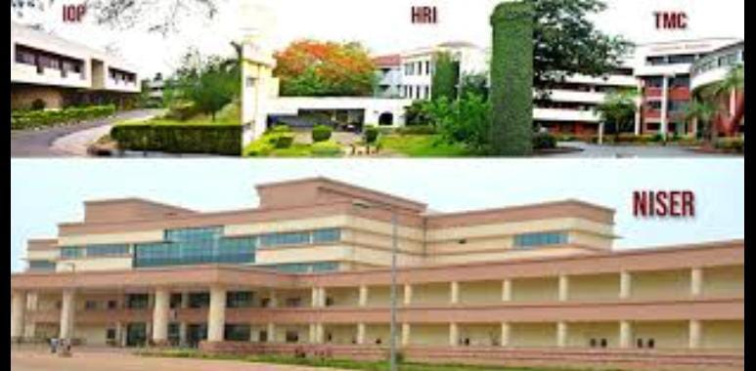
ACADEMIC PRORAMMES
For developing a well trained central government engineers in the area of nuclear science and engineering, DAE established the "Training School" in 1957 at Trombay, Mumbai. Courses are conducted at all CIs and at BARC Training schools
RANKING
The National Institutional Ranking Framework (NIRF) ranked Homi Bhabha National Institute 30th overall in India and 14th among universities in 2020. In NIRF 2021, in University category, it is ranked 18th.
The Nature Index has ranked HBNI 10th in the world under the ranking of "Nine universities under 50 in the fast lane", published in 2019.
The Nature Index 2020 Annual Tables highlight the institutions and countries that dominated high quality research in the natural sciences in 2019 as tracked by Nature Index. The rankings are based on an institution's or country's share of articles published in the 82 prestigious scientific journals selected by an independent panel of experts and tracked by the Nature Index database. According to Nature Index 2020, HBNI ranked at second position, behind Indian Institute of Science, among all academic institutions in India based on publications (count as well as share) during the period 1 March 2019 to 29 February 2020.
MISSION
To encourage pursuit of excellence in sciences (including engineering sciences) and mathematics in a manner that has major significance for the progress of indigenous nuclear technological capability.

VISION
i) To provide an academic framework for integrating basic research with technology development.
ii) To encourage inter-disciplinary research.
iii) To nurture an environment for attracting high quality manpower in the sciences including engineering sciences to take up a career in nuclear science and technology and related areas.
GUIDING VALUES
i) Always adhere to highest ethical standards.
ii) Put good of students first.
iii) Value excellence in research and foster innovation and creativity.
iv)Recognize importance of science for the development of society.
REFERENCES
  - "The Beginning". Homi Bhabha National Institute. Retrieved 16 October 2015.
  - ^ "Setting up of Homi Bhabha National Institute" (PDF). Retrieved 24 December 2017.
  - ^ "HBNI -> Council of Management". Homi Bhabha National Institute. Retrieved 19 November 2017.
  - ^ "Comparative assessment of the (Deemed to be University)" (PDF). Government of India, Ministry of Human Resource Development.
  - ^ "Central Educational Institutions" (PDF). Ministry of Law and Justice.
  - ^ www.hbni.ac.in http://www.hbni.ac.in/main/NAAC/naacloi.html. Retrieved 23 November 2017. {{cite web}}: Missing or empty |title= (help)
  - ^ "Dr Manmohan Singh announced the approval" (PDF). BARC. Retrieved 4 June 2005.
  - ^ "Setting up of Homi Bhabha National Institute" (PDF). Retrieved 24 December 2017.
  - ^ "Integrating the function of a university to a work place to promote post-academic research" (PDF). Retrieved 26 October 2019.
  - ^ "Development of human resources for Indian nuclear power programme", Sadhana, Vol. 38, Part 5, October 2013, pp 1051-1064.
  - ^ [1]. The Hindu (2011-12-26). Retrieved on 2023-05-14.
  - ^ Jump up to:a b "National Institutional Ranking Framework 2020 (Overall)". National Institutional Ranking Framework. Ministry of Education. 11 June 2020.
  - ^ Jump up to:a b "National Institutional Ranking Framework 2020 (Universities)". National Institutional Ranking Framework. Ministry of Education. 11 June 2020.
  - ^ "Nine universities under 50 in the fast lane". natureindex.com. Retrieved 3 May 2020.
  - ^ "Institution Output 1 March to 29 February 2020". natureindex.com. Retrieved 19 May 2020.
  - ^ "HBNI - The Beginning". www.hbni.ac.in. Retrieved 8 February 2022.

