- Centre for Materials for Electronics Technology(C-MET)
Vishwesh R.Joshi and Rahul Waykar(S.Y.B.Sc.)
INTRODUCTION

C-Met is a receptor tyrosine kinase belonging to the MET (MNNG HOS transforming gene) family, and is expressed on the surfaces of various cells. Hepatocyte growth factor (HGF) is the ligand for this receptor. The binding of HGF to c-Met initiates a series of intracellular signals that mediate embryogenesis and wound healing in normal cells. However, in cancer cells, aberrant HGF/c-Met axis activation, which is closely related to c-Met gene mutations, overexpression, and amplification, promotes tumour development and progression by stimulating the PI3K/AKT, Ras/MAPK, JAK/STAT, SRC, Wnt/β-catenin, and other signaling pathways. Thus, c-Met and its associated signaling pathways are clinically important therapeutic targets. In this review, we elaborate on the molecular structure of c-Met and HGF and the mechanism through which their interaction activates the PI3K/AKT, Ras/MAPK, and Want signaling pathways. We also summarize the connection between c-Met and RON and EGFR, which are also receptor tyrosine kinases. Finally, we introduce the current therapeutic drugs that target c-Met in primary tumors, and their use in clinical research.
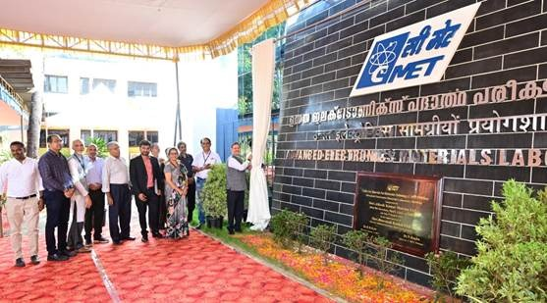

Scientific Society under Department of Electronics and Information Technology.
Ministry of Communications and Information Technology,Government of India,
New Delhi – 110003
Centre for Materials for Electronics Technology (C-MET) has been set up as a Registered Scientific Society in March 1990 under Department of Information Technology (formerly Department of Electronics) as a unique concept for development of viable technologies in the area of materials mainly for electronics. C-MET is operating with 3 laboratories located at Pune (Head Quarters), Hyderabad and Thrissur with specialized research mandate at each place.
With just over 25 years since its first discovery, the c-MET receptor is emerging as an important target for personalized cancer therapy. Inhibition of c-MET receptor activity in vivo has shown promising results in inhibition of tumour cell growth and in overcoming resistance to anti-EGFR therapy, which has now becoming a standard therapy for patients with advanced NSCLC. Results from early phase clinical trials are starting to demonstrate the importance of c-MET/HGF signalling in cancer biology. The challenge will be to explore and discover further other important crosstalk mechanisms involving this pathway, which could lead to further improvement in the efficacy of novel anticancer therapies and improve patient survival.
- Mission
The mission of C-MET is to develop knowledge base in the electronic materials and their processing technology and become a source of critical electronic materials, know-how and technical services for the industry and other sectors of the economy.
- Core Programmes
- Integrated Electronics Packaging
- Nanomaterials and Devices
- Ultra High Purity Materials
- Materials for Renewable Energy
- Piezo Sensors and Actuators
- C-MET, Pune, India invites applications for Research Scientists Position at C-MET from eligible and interested candidates

Dedicated to the furtherance of competent research and development in the firmament of Electronic Materials, the Centre for Materials for Electronics Technology (C-MET) functions as an autonomous scientific society under Dept. of Information Technology, Ministry of Communications and Information Technology (MCIT), Govt. of India. Besides augmenting core competence, C-MET envisions the attainment of self-sufficiency in the sphere of Electronic materials, components, and devices to cater to India’s strategic and industrial- applications, exploiting indigenous resources of raw materials. Research Scientist & Research Associate at C-MET
Research/Job Area- In related areas: Location- Pune
- Eligibility/Qualification –
Essential qualification :
PhD with minimum one year or M.Tech with minimum three years industrial experience in embedded system, electronic circuit designs and product realization.
Desirable: Experience in IoT system design with expertise in interfaces to Bluetooth/Zigbee/Wifi/Lora, Sensor product design and system integration with expertise in hardware and communication protocols like UART, 12C, SPI, Expertise in electronic circuit design and multilayer PCB design, Good knowledge in International protocols and standards for electronics product design especially for sensors, Good understanding of microelectronics, working experience as team leader in an Industry.
- MAJOR ACTIVITIES OF C-MET
C-MET's R&D activities at present include development of thick film materials, polymers for electronics, specialty chemicals and glasses, ultra high purity and refractory metals, semiconductors, electronic ceramics and fine powder processing. C-MET undertakes R&D projects, sponsored research, technology transfer, and consultancy and technical services.
- RESEARCH AND DEVELOPMENT
C-MET carries research and development on electronic materials and their processing keeping in view the development in the electronic and IT industry all over the world. Many of these programmes are for advanced electronic materials and processes with partial funding coming from various national and international funding agencies.
SPONSORED RESEARCH
C-MET will partner industry(ies) in developing new materials and processes useful to the electronic s and information technology sector under sponsored research projects. The work may include new product ideas, novel materials and processes, product and process development, modification of existing product/process for yield improvement and/or cost reduction and any other mutually agreed area.
- TECHNOLOGY TRANSFER
C-MET is continuously engaged in activity relating to technology transfer. It can take up pilot plant studies, feasibility studies, production start-up activity, etc. so that the technologies developed within C-MET can be effectively transferred to the industry.
- CONSULTANCY
C-MET can provide expert advice and troubleshooting service to the industry for various day-to-day problems, yield improvement and data interpretation.
- TECHNICAL SERVICES
C-MET provides sophisticated material characterization and testing services like XRD , SEM-EDAX, GD-OES, AAS, CHONS, HPLC, GPC, Ion Chromatography, Particle Size Measurement, , LCR Measurement, etc. for the industry. It can also provide other technical services like synthesis and supply of special materials and components, leasing of equipment, training to industry staff and supply of scientific and technical information. Out of the above activities direct customer services extended by C-MET is the technical services through characterization and testing.
Centres:HEAD QUARTERS : PUNE
CMET's R&D activities have been implemented in three laboratories at Pune, Hyderabad and Thrissur. The laboratory at Pune functions as headquarters and extends central coordination support. Each of these laboratories has its own areas of specialization with requisite infrastructure and expertise. This approach has proven to be successful in creating core competence at each laboratory.
- PUNE LABORATORY
Li-ion batteries, LTCC Packaging materials, Specialty Polymers,
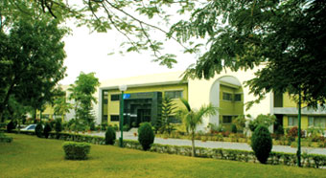
Nano-materials/composites

- HYDERABAD LABORATORY
Ultra Pure Materials: E-Waste and RoHS compound semiconductors, Ultra High Pure Metals and Semiconductors; Refractory Metals, alloys and Special Materials
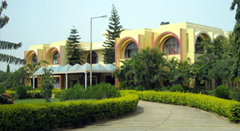
THRISSUR LABORATORY
Electronic Ceramics: Microwave dielectrics, Multilayer Ceramics, Actuators and Sensors, Nanomaterials and thin films, Aerogels and Graphene super capacotors
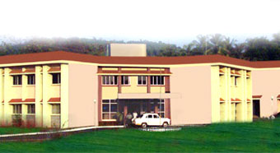

- Reference

- https://cmet.gov.in/terms-and-conditions.
- https://www.ncbi.nlm.nih.gov/pmc/articles/PMC3225017/&sa=U&ved=2ahUKEwjr2omL4ZqCAxUURmcHHcCSDwAQFnoECBEQAQ&usg=AOvVaw3-tOwSMnjlijsedUbIehUW
- https://www.meity.gov.in/content/c-met&sa=U&ved=2ahUKEwjUnKGv4ZqCAxXdTWwGHYAZAnkQFnoECCIQAQ&usg=AOvVaw2P2fSAZv49kbeUDTT8nq3I

