Ceropegia oculata Hook.
Family: Asclepiadaceae
Herbs, twining; stems branched, slightly swollen at nodes. Leaves broadly ovate or ovate-oblong, apex acute or shortly acuminate. Flowers few in lateral umbellate cyme; peduncles hairy; base inflated, narrow in neck, mouth funnel-shaped.
Fls.& Frts. : July- October.
IUCN category : Critically endangered
Uses : Fever to children: Tubers are given orally to children.
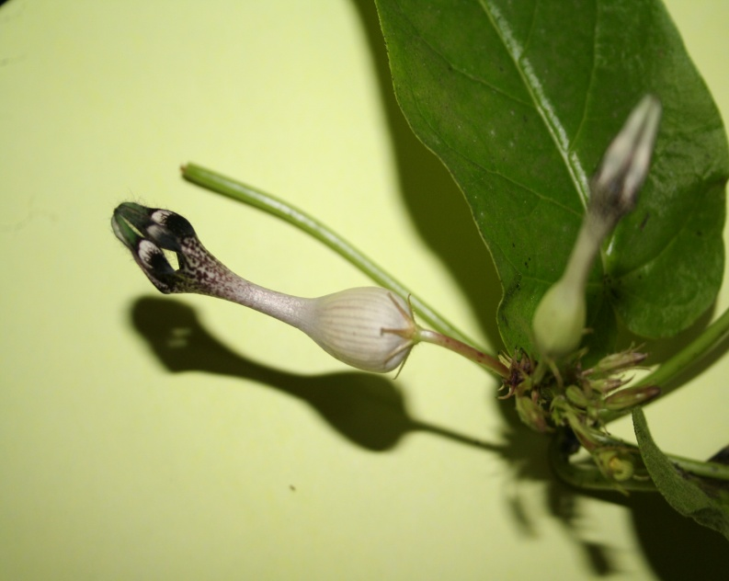 Ceropegia oculata Hook.

Dr. R. L. Ghalme,Head, department of Botany.

